Reading #11
Training Muscles to Become Stronger

Introduction
Weightlifting began as a spectator sport in America in the early 1840s, practiced by “strongmen” who showcased their prowess in traveling carnivals and sideshows. By the mid-1880s, measuring muscular strength became more commonplace, particularly in schools and colleges as one of several indicators of an individual fitness. In 1897 at a meeting of College Gymnasium Directors, strength test contests were established to determine overall body strength based on measures of back, leg, arm, and chest strength. The first 5 colleges to rank in the 1898–1899 contest were Harvard, Columbia, Amherst, Minnesota, and Dickinson.
By the mid-1900s, physical culture specialists, body builders, competitive weight lifters, field event athletes, and some wrestlers used “weightlifting” exercises. Most other athletes, however, refrained from lifting weights for fear it would slow them and increase muscle size so they would lose joint flexibility and become “muscle-bound.” Research in the late 1950s and early 1960s silenced this myth by showing that muscle-strengthening exercises did not reduce movement speed or flexibility. In longitudinal experiments with untrained healthy subjects, heavy-resistance exercises actually increased speed and power.

Foundations For Studying Muscular Strength
The scientific foundations for incorporating strength training as part of an athlete’s competitive training can be traced to the Chinese in 3600 BC. In the Chou dynasty (1122-249 BC), conscripts had to pass weight-lifting tests before they became soldiers. Weight training also took place in ancient Egypt and India; sculptures and illustrations depict athletes training with heavy stone weights. Women also practiced weight training; wall mosaics recovered from Roman villas showed young girls exercising with hand-held weights. During the “Age of Strength” in the sixth century, weight lifting competitions often took place between soldiers and athletes. Galen, the famous early Greek physician (Lecture 2), refers to exercising with weights (halters) in his various writings.
The quest to develop muscular strength led to different “systems” of resistance training. The first “modern” text detailing a strength training system appears to be the 1561 text by Sir Thomas Elyot, “The Boke Named The Govuenour” (Elyot’s treatise establishes a detailed curriculum of study, including intellectual and artistic pursuits and physical education, about the role of gymnastics and strength development standards to which a governor should aspire). In the 1860s, Archibald MacLaren, a Scotsman, compiled the first system of physical training with dumbbells and barbells for the British army.

Objectives of Resistance Training
The study of strength development provides practical applications in six areas: Weight lifting and power lifting competition

- Body building (for aesthetic goals
- Fitness and health enhancement
- Physical therapy; rehabilitation from injury
- Sport-specific resistance training
- Understanding muscle function and structure
- Definition of Terms in Resistance Training

Terms and jargon abound in the area of resistance training, yet certain terms consistently appear in the research literature. Below is listed a selection of common resistance training terms.
Cheating. Breaking from strict form (e.g., rather than maintaining an erect upper body when performing a standing arm curl, a slight body swing at the start the movement allows the person to lift a heavier weight (or the same weight more times). Cheating increases injury if performed improperly.
Circuit Resistance Training (CRT). Series of resistance training exercises performed in sequence with minimal rest between exercises. More frequent repetitions with less resistance activate the cardiovascular system to produce an aerobic training effect.
Concentric Action. Muscle shortening during force application
Dynamic Constant External Resistance (DCER). Training: Resistance training where external resistance or weight does not change; joint flexion and extension occurs with each repetition. Formerly (but incorrectly) referred to as “isotonic” exercise.
Eccentric Action. Muscle lengthening during force application.
Exercise Intensity. Muscle force expressed as a percentage of muscle’s maximum force-generating capacity or some level of maximum.
Isokinetic Action. Muscle action performed at constant angular limb velocity.
Isometric Action. Muscle action without change in muscle length.
Maximal Voluntary Muscle Action (MVMA). Maximal force generated in one repetition (1-RM), or performing a series of submaximal actions to momentary failure.
Muscular Endurance. Sustaining maximum (or submaximum) force; often determined by assessing maximum number of exercise repetitions at a percentage of maximum strength.
Overload. A muscle acting against a resistance normally not encountered (unaccustomed stress).
Periodization. Variation in training volume and intensity over a specified time period; goal to prevent staleness and peak physiologically for competition.
Plyometrics. Resistance training involving eccentric-to-concentric actions performed quickly so a muscle stretches slightly prior to the concentric action; utilizes stretch reflex to augment muscle’s force-generating capacity.
Power. Rate of performing work (Force x Distance ÷ Time, or Force x Velocity). Power applied to weightlifting relates to mass lifted times vertical distance it moves, divided by the time to complete the movement; if 100 lbs moves vertically 3 feet in one second, the power generated = 100 lb x 3 ft ÷ 1 s or 300 ft-lb•s⁻¹.
Progressive Overload. Incrementally increasing the stress placed on a muscle as it produces greater force or greater endurance.
Range of Motion (ROM). Maximum movement through an arc of a body joint.
Repetition. One complete exercise movement, usually consisting of concentric and eccentric muscle actions or one complete isometric muscle action.
Repetition Maximum (RM). Greatest force generated for one repetition of a movement (1-RM).
Set. Pre-established number of repetitions performed.
Sticking Point. Region in an exercise movement (against a set resistance) that provides greatest difficulty completing the movement.
Strength. Maximum force-generating capacity of a muscle or group of muscles.
Torque. Force that produces a turning, twisting, or rotary movement in any plane about an axis (e.g., movement of bones about a joint); commonly expressed in Newton-meters (Nm).
Training Volume. Total work performed in a single session.
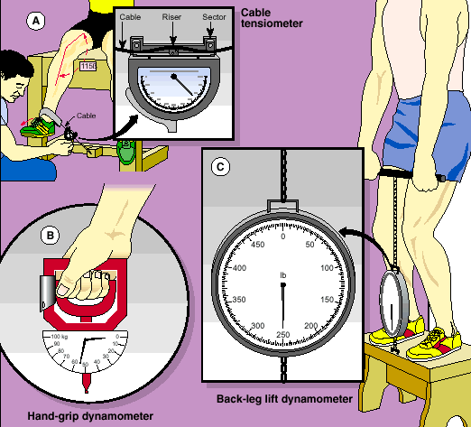
Variable Resistance Training. Training with equipment that uses a lever arm, cam, or pulley to alter the resistance to match increases and decreases in muscle force capacity throughout a joint’s ROM.
Figure 1. Strength measures.

Measurement of Muscular Strength
Four methods generally assess muscular strength, i.e., the maximum force, tension, or torque generated by a muscle or muscle groups: Cable tensiometry, dynamometry, one-repetition maximum, and computer assisted electromechanical and isokinetic determinations.

Cable Tensiometry
Figure 1A shows a cable tensiometer measuring muscular force during knee extension. Increased force on the cable depresses a riser over which the cable passes; this deflects the pointer and indicates the subject’s strength score. The application of the tensiometer for strength measurements differs considerably from its original use for measuring tension on steel cables linking various parts of an airplane.

Dynamometry
Figures 1B and C display handgrip and back-lift dynamometers to assess static strength. Both devices operate on the principle of compression. Application of external force to the dynamometer compresses a steel spring and moves a pointer. By knowing how much force must move the pointer a given distance, one can determine how much external “static” force has been applied to the dynamometer.

One-Repetition Maximum
The one-repetition maximum (1-RM) technique serves as a dynamic method for measuring muscular strength. To test 1-RM for single or multiple muscle groups, the initial weight should be close to but below maximum lifting capacity. Depending on the muscle group, increments in weight lifted range from 1 to 5 kg. The 1-RM maneuver requires concentric and eccentric muscle actions, but only the concentric phase of the action evaluates 1-RM.

Computer-Assisted Electromechanical and Isokinetic Determinations
Microprocessor technology integrated with exercise equipment provides a unique way to quantify muscular force during a variety of movements. Modern instrumentation measures force, acceleration, and velocity of body segments in various movement patterns. Force platforms can measure the external application of muscular force by limbs during jumping. Other electromechanical devices measure forces generated during all movement phases of cycling, rowing, supine bench press, seated and upright leg press, and exercises for other trunk, arm, and leg movements weight an individual can bench press or squat.

Strength Testing Considerations
The following factors affect strength testing, regardless of assessment method. It is necessary to:

- Give standardized instructions.
- Allow a warm-up of uniform duration (e.g., 3 to 5 minutes) and intensity (e.g., 50% of previously established 1-RM depending on muscle group).
- Provide adequate practice several days before testing to minimize a “learning” component that could compromise initial results or inflate evaluation of true training effects.
- Ensure constancy of limb position and/or measurement angle.
- Provide several trials (repetitions) to establish a criterion score.
- Administer strength tests with established reliability (reproducibility) of scores.
- Consider individual differences in body size and composition when evaluating strength scores among individuals and groups.

Physical Testing in the Occupational Setting
No one “best” measure of muscular strength exists. Each individual possesses an array of muscular “strengths” and “powers.” Often, these expressions of physiologic function and performance are not co-related to each other. Likewise, a person has diverse capabilities for expressing aerobic capacity, depending on the muscle mass exercised. In the occupational setting, a 12-minute run to infer aerobic capacity for fire fighting or lumbering (both requiring significant upper body aerobic function), or static grip or leg strength to evaluate the diverse strengths and powers required in such occupations, would be physiologically unwise in light of current knowledge of performance specificity. Measurement in the occupational setting requires attention not only to faithfully replicating specific job tasks, but also measuring the physiological demands of the work for intensity, duration, and pace.

Important Issues for Training Muscles to Become Stronger
Training muscles to become stronger requires different principles and adherence to specific guidelines.

Overload and Intensity
Muscular strength training requires application of the overload principle by use of weights (dumbbells or barbells), immovable bars, straps, pulleys, or springs, and oil, air, and water hydraulic devices. In each case, the muscle responds to the intensity of the overload rather than to the actual form of overload.
The amount of overload is usually expressed as a percent of the maximum force-generating capacity (1-RM) of a non-fatigued muscle or muscle group. Performing a voluntary maximal muscle action means the muscle must move against as much resistance as its present capacity level allows. Although a partially fatigued muscle cannot generate the same force as a non-fatigued muscle, the last repetition in a set to momentary failure still represents a voluntary maximal muscle action. Muscular overload in resistance training usually requires voluntary maximal muscle actions.
Three approaches (either singularly or in combination) apply muscular overload in resistance training:
- Increase load or resistance
- Increase number of repetitions
- Increase speed of muscle action
Muscular overload, referred to as training intensity, represents the most important concept in strength development; it relates to the necessity for training above a minimum threshold level to induce a training response. Minimal intensity for overload occurs between 60 to 70% of 1-RM. This means that performing a large number of repetitions with a light resistance generally produces minimal strength gains.

Muscle Actions
Concentric action represents the most common form of muscle action; it occurs in dynamic activities where the muscle shortens and joint movement occurs as tension develops. Figure 2A illustrates a concentric muscular action by raising a dumbbell from the extended to flexed elbow position. Because a concentric muscle action produces actual muscle shortening, the word “contraction” frequently describes this process.
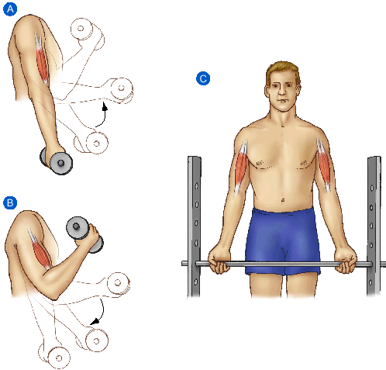
Eccentric action (also called lengthening, stretching, or plyometric) occurs when external resistance exceeds muscle force, and the muscle lengthens while developing tension. Figure 2B shows a weight slowly lowered against the force of gravity. The muscles of the upper arm increase in length as they provide braking action to prevent the weight from crashing to the floor.
Figure 2. Muscular force during (A) concentric (shortening), (B) eccentric (lengthening), and (C) isometric (static) actions.
Isometric action (also called static or stationary) occurs when a muscle attempts to shorten but cannot overcome the resistance. Considerable muscular force can be generated during an isometric action with no noticeable muscle lengthening or shortening or joint movement. Figure 2C illustrates an isometric muscular action.
The term isotonic commonly describes concentric and eccentric muscle actions because movement occurs in both cases. The term isotonic comes from the Greek isotonos (iso meaning the same or equal; tonos, tension or strain.) Actually this term should not be applied to most dynamic muscle actions that involve movement because the muscle’s force-generating capacity varies as the joint angle changes; thus, force output does not remain constant through the ROM. Dynamic constant external resistance (DCER) provides a more useful term for strength (resistance) training in which external resistance or weight does not change, but lifting (concentric) and lowering (eccentric) phases occur during each repetition. DCER implies that the external weight or resistance remains constant throughout the movement.

Force:Velocity Relationship
Different physical activities require different amounts of strength (force) and power. Absolute or peak force generated in a movement depends upon the speed of muscle lengthening and shortening. Figure 3 shows the force:velocity relationship for concentric and eccentric actions. Muscles shorten at different velocities (horizontal axis of graph) depending on the load placed on them. As the load increases, maximum velocity decreases. Conversely, a muscle’s force-generating capacity (vertical axis of graph) rapidly declines with increased shortening velocity. This explains the difficulty in attempting to move a heavy weight rapidly.
A concentric action becomes a lengthening (eccentric) action when the external load exceeds a muscle’s maximum force capacity (noted as point 0 on the vertical axis.) Rapid eccentric actions generate the greatest muscular force. This may explain muscle damage and delayed muscle soreness while doing eccentric exercise. Force at zero velocity shortening (isometric action) exceeds all forces generated with concentric actions. Muscle fiber type also influences the force-velocity relationships; fast-twitch muscle fibers produce greater muscle force at fast movement speeds than slow-twitch fibers.

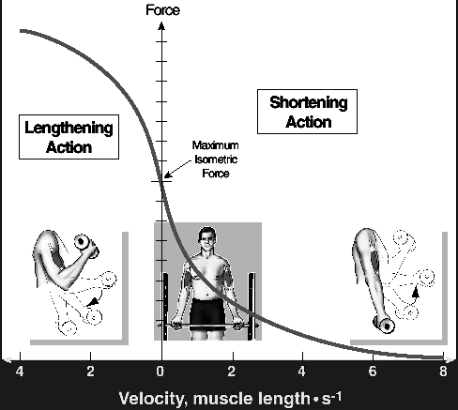
Power-Velocity Relationship
Figure 3. Maximum force-velocity relationship for shortening and lengthening muscle actions. Rapid shortening velocities generate the least maximum force. Shortening velocity becomes zero (maximum isometric force) when the curve crosses the y-axis.
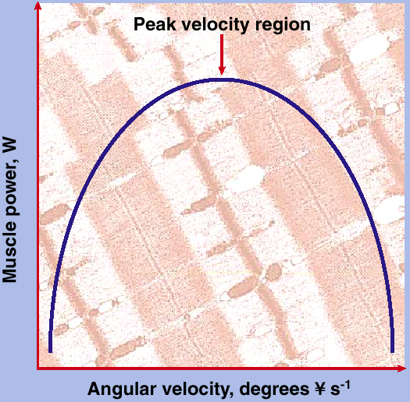
Figure 4 shows an “inverted U” relationship between a muscle’s maximal power output and its speed of limb movement. Peak power rapidly increases with increasing velocity to a peak velocity region. Thereafter, maximal power output decreases because of the significant reduction in maximum force at faster movement speeds (Figure 15-4.) Thus, each muscle group has an optimum movement speed to produce maximum power. At any movement velocity, greater peak power occurs in fast-contracting fibers than slow-contracting fibers due mainly to the biochemical differences between fibers.
Figure 4. Power-velocity relationship. Power (work per unit time) increases as a function of movement velocity to a peak velocity region.

Load:Repetition Relationship
The total work accomplished by muscle action depends on the load (resistance) placed on the muscle. One can perform high repetitions with light loads, but few repetitions with near maximal loads.

Sex Differences In Strength
Two approaches can determine whether true sex differences exist in muscular strength.
- Absolute basis (as total force exerted)
- Relative basis (as force exerted in relation to body mass, fat-free body mass, or muscle cross-sectional area)

Absolute Strength
When comparing absolute strength (total force in pounds or kilograms), men achieve considerably higher strength scores than women for all muscle groups, regardless of test mode. Sex differences in strength are particularly apparent for upper body strength evaluations; women exhibit about 50% less strength than men. In lower body strength, women achieve 20 to 30% below the scores of male counterparts. Exceptions usually include strength-trained female track and field athletes and bodybuilders who train diligently with overload resistance exercise to significantly increase the strength of specific muscle groups.

Relative Strength
Human skeletal muscle in vitro generates 16 to 30 Newton’s (N) maximum force per square centimeter of muscle cross-sectional area (MCSA) regardless of sex. In the body (in vivo), force-output capacity varies depending on the arrangement of bony levers and muscle architecture.
Individuals with the largest MCSA generate the greatest muscular force. The strong, linear relationship between strength and muscle size (r = 0.95) indicates little difference in arm flexor strength for the same size muscle in men and women.
Resistance Training for Children
While resistance training for children has gained in popularity, its benefits and possible risks remain relatively unknown. Because skeletal development is not complete in young children and adolescents, obvious concern arises about the potential for bone and joint injury with heavy muscular overload. Furthermore, one might question whether resistance training can induce significant strength improvements at a relatively young age because the hormonal profile continues its progressive development (particularly for the tissue-building hormone testosterone). Limited evidence indicates that closely supervised resistance training programs using concentric-only muscle actions with high repetitions and low resistance significantly improve children’s muscular strength with no adverse effect on bone or muscle.

Systems of Resistance Training
Five fundamentally different but interrelated systems of training result in muscular strength development:
- Isometric training
- Dynamic constant external resistance training
- Variable resistance training
- Isokinetic training
- Plyometric training

Isometric Training (Static Exercise)
Isometric strength training gained popularity between 1955 and 1965. Research in Germany during this time showed an increase in isometric strength of about 5% a week from only a daily, single, two-thirds maximum isometric action for six-seconds duration! Repeating this action five to 10 times produced greater increases in isometric strength. Gains in strength from this simple exercise overload seemed beyond belief, and subsequent research demonstrated that isometric strength gains progressed at a much slower rate. Research also showed that gains in strength from isometrics related to repetitions, duration of muscle action, and training frequency.

Dynamic Constant External Resistance (DCER) Training
This popular system of resistance training involves lifting (concentric) and lowering (eccentric) phases with each repetition using weight plates (barbells and dumbbells) or exercise machines that feature different applications of muscle overload.

Progressive Resistance Exercise
Researchers in rehabilitation medicine following World War II devised a method of resistance training to improve the force-generating capacity of previously injured limbs. Their method involved three sets of exercise, each consisting of 10 repetitions done consecutively without rest. The first set involved one-half the maximum weight lifted 10 times or one-half 10-RM; and the second set used three-quarters 10-RM; the final set required maximum weight for 10 repetitions or 10-RM. As patients trained and became stronger, 10-RM resistance increased periodically to match strength improvements. This technique of progressive resistance exercise (PRE) , a practical application of the overload principle, forms the basis for most strength conditioning programs.

Variations of PRE
Variations of PRE have determined an optimal number of sets and repetitions, including frequency and relative intensity of training, to improve strength. The findings can be summarized as follows:

- Performing between 3-RM and 9-RM is the most effective number of repetitions to increase muscular strength.
- PRE training once weekly with only 1-RM for one set increases strength significantly after the first week of training, and each week up to at least the sixth week.
- No particular sequence of PRE training with different percentages of 10-RM produces more effective strength improvement, provided each training session consists of one set of 10-RM.
- Smaller strength increases occur when performing one set of an exercise rather than two or three sets, and three sets produces greater improvement than two sets.
- For beginners, significant strength increases occur with only one training day weekly, but the optimum number of training days per week with PRE remains unknown.
- When PRE training uses several different exercises, training four or five days a week may be less effective for increasing strength than training two or three times weekly. More frequent training may prevent sufficient recuperation between exercise sessions, which could retard neuromuscular adaptation and strength development.
- A fast rate of movement for a given resistance generates greater strength improvement than lifting at a slower rate. Neither free weights nor concentric-eccentric-type weight machines or “isotonic” devices produce inherently superior results compared with other strength development methods.

Variable Resistance Training
A limitation of typical DCER weight-lifting exercise is failure of muscles to generate maximum force through all phases of the movement. Variable resistance training equipment alters resistance to movement by use of a lever arm, irregularly shaped metal cam, or pulley to match increases and decreases in force in relation to joint angle (lever characteristics) throughout a ROM. This adjustment facilitates strength gains allowing near-maximal force production throughout a ROM.
Research has shown that a single cam cannot possibly compensate fully for individual differences in mechanics and force applications at all phases of the particular movement. Variations in limb length, point of attachment of muscle tendons to bone, body size, and strength at different joint angles all affect maximum force generated throughout a ROM. In most cases, cams produce too much resistance during the first half and too little resistance during the second half of flexion and extension exercises. Despite these limitations, cam devices produce strength improvements comparable to other types of equipment.

Isokinetic Training
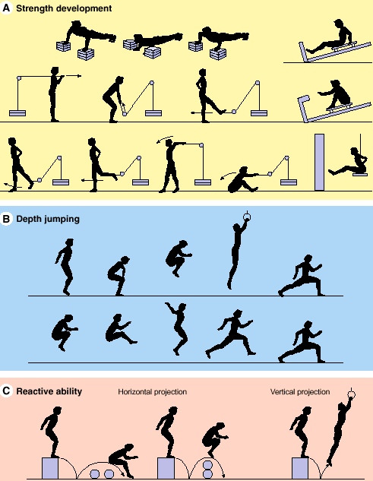
Isokinetic resistance training differs from isometric and DCER methods; it employs a muscle action performed at constant angular limb velocity. Unlike dynamic resistance exercise, isokinetic exercise does not require a specified initial resistance; rather, the isokinetic device controls movement velocity. The resisting force offered by the isokinetic machine cannot be accelerated; any force applied against the device’s lever results in an opposing force, which thwarts any increase in movement velocity. The muscles exert maximal force throughout the ROM while shortening (concentric action) at a specific velocity. Advocates of isokinetic training argue that ability to exert maximal force throughout the full ROM optimizes strength development. Also, concentric-only actions minimize muscle and joint injury and resulting pain.

Plyometric Training
Athletes who require specific powerful movements (e.g., football, volleyball, sprinting, and basketball) perform exercise training termed plyometrics. With plyometric training, movements make use of the inherent stretch-recoil characteristics of skeletal muscle and neurological modulation via the stretch or myotatic reflex. Consider walking: When the foot first hits the ground, the quadriceps initially act (stretch) eccentrically, then briefly isometrically, before the shortening phase of a muscle’s action begins. The term stretch-shortening cycle describes the sequence of sequentially linked eccentric-isometric-concentric muscle actions. When stretching occurs rapidly, stored elastic energy in muscle fibers and initiation of the myotatic reflex combine to produce a powerful concentric action.
Vertical jumping provides an example of the stretch-shortening cycle to enhance performance. During a normal vertical jump, the jumper bends at the knees and hips (eccentric action of extensors), pauses briefly (isometric action), and rapidly reverses direction (concentric action) to jump upward as high as possible. If this same movement stops for several seconds following the knee bend (just before reversing movement direction), the subsequent jump (concentric action) produces a lower jump height compared with a performance that uses the complete stretch-shortening cycle.

Comparison of Training Systems
Few research studies directly compare different training systems within the same experimental protocol. Some studies compare two different training systems (e.g., isometric versus variable resistance; isometric versus isokinetic; isometric versus eccentric). The results generally support the specificity and individual differences principles. When training and testing incorporate the same system, relatively large strength increases occur, regardless of type of training system. When testing uses a different system than in training, smaller training-induced strength increases occur, and in some experiments become nonexistent. Difficulties arise in trying to compare different training systems because of methodological problems equating training volume (sets and repetitions), total work, total training time, and most importantly, training intensity. This makes it almost impossible to directly “prove” one strength training system “better” than another. Moreover, some individuals simply respond more favorably to one system and not another.

Adaptations To Resistance Training
Resistance training produces acute responses and chronic adaptations. An acute response refers to immediate changes (in muscle or other cells, tissues, or systems) that occur during or immediately after a single bout of resistance exercise. For example, enzyme levels and energy stores change in response to specific muscle actions. Chronic changes take place with repeated stimuli over the course of a training regimen. Adaptation refers to how the body adjusts to repeated stimuli. The body responds acutely to a given stress, while repeated exposure to the stimulus produces long-lasting changes that affect the acute response over time (e.g., less disruption in cellular integrity [muscle damage] with a given level of exercise.)
Adaptations to resistance training occur in diverse body systems from the cellular to systemic level. Six factors impact development and maintenance of muscle mass. These factors include: genetics; nervous system activation; environmental factors; endocrine factors; nutritional status; amount of physical activity Unmistakably, genetics provides the governing frame of reference that influences the effect of each other factor on the ultimate training outcome. Muscular activity, however, contributes little to tissue growth without appropriate nutrition to provide essential building blocks. Similarly, training outcome depends on specific hormones and patterns of nervous system activation. Without overload, each of the other factors remains relatively ineffective for inducing strength development.

Fast- and Slow-Twitch Muscle Fibers
Exercise physiologists have applied invasive biopsy techniques to study the functional and structural characteristics of human skeletal muscle. The biopsy procedure uses a special needle to puncture the muscle and obtain approximately 20 to 40 mg of tissue (the size of a grain of rice) for chemical and microscopic analysis. Two distinct types of fiber have been identified in human skeletal muscle: fast-twitch and slow-twitch. The proportion of each fiber type within a particular muscle probably remains fairly constant throughout life.

Fast-Twitch Fiber
Fast-twitch muscle fiber, also known as type II fiber, possesses a high capacity for anaerobic ATP production during glycolysis. These fibers possess a rapid contraction speed; they become activated in sprint activities that depend almost entirely on anaerobic metabolism for energy. The metabolic capabilities of fast-twitch fibers also become important in stop-and-go or change-off-pace sports like basketball, soccer, lacrosse, and field hockey These sports often require rapid energy transfer through anaerobic metabolism.

Slow-Twitch Fiber
The slow-twitch or type I muscle fiber has a contraction speed about one-half as fast as its fast-twitch counterpart. Slow-twitch fibers possess numerous mitochondria and a high concentration of enzymes required to sustain aerobic metabolism. They demonstrate a much greater capacity to generate ATP aerobically than their fast-twitch counterparts. As such, slow-twitch muscle fiber activation predominates in endurance activities that depend almost exclusively on aerobic metabolism. Middle-distance running or swimming, or basketball, field hockey, and soccer, require a blend of both aerobic and anaerobic capacities. Both types of muscle fibers become activated in such sports.
From the preceding discussion, do you think that the predominant fiber type in specific muscles contributes to success in a particular sport or activity?

Muscle Adaptations
Psychologic inhibitions and learning factors greatly modify muscular strength, but anatomic and physiologic factors within the muscle determine the ultimate limit of strength development. The gross and ultrastructural changes in muscle with chronic resistance training generally produce adaptations in the contractile apparatus, accompanied by substantial gains in muscular strength and power. An increase in the muscle’s external size represents the most visible adaptation to resistance training. Muscle fiber hypertrophy (increase in size of individual fibers) usually explains increases in gross muscle size, although increased fiber number (fiber hyperplasia) provides a hotly debated alternative hypothesis.

Muscle Fiber Hypertrophy
Increases in muscle size (hypertrophy) with resistance training for men and women can be viewed as a fundamental biologic adaptation. Weightlifters’ and body builders’ extraordinarily large muscle size and definition results from enlargement of individual muscle cells, mainly fast-twitch fibers. Growth takes place from one or more of the following adaptations:

- Increased contractile proteins (actin and myosin)
- Increased number and size of myofibrils per muscle fiber
- Increased amounts of connective, tendinous, and ligamentous tissues
- Increased enzymes and stored nutrients

Not all muscle fibers undergo the same degree of enlargement with resistance training. Muscle growth depends on the muscle fiber type activated and recruitment pattern. With initiation of heavy resistance exercise training, alterations in various muscle proteins begin within several workouts. As training continues, contractile proteins increase in conjunction with enlargement of muscle fiber cross-sectional area.

Muscle Remodeling: Can Fiber Type Be Changed?
Fourteen men performed three sets of 6-RM leg squats three times per week to evaluate the effects of eight weeks of resistance training on muscle fiber size and composition in leg extensor muscles. Biopsies from the vastus lateralis before and after training showed significant increases in the volume of fast-twitch fibers. However, no change resulted in the percentage distribution of fast- and slow-twitch muscle fibers. This finding supported previous short-term studies of overload training and muscle fiber type. Several months of resistance training in adults does not alter basic fiber composition of skeletal muscle. It remains unknown whether specific training early in life, or prolonged training such as engaged in by Olympic-caliber athletes, actually changes a muscle fiber’s inherent twitch (speed of shortening) characteristics. Current consensus maintains that genetic factors determine an individual’s predominant muscle fiber distribution. Significant muscle fiber type transformation (i.e., transforming Type I to Type II fibers) probably does not occur in healthy individuals.

Muscle Hypertrophy: Male Versus Female
Computed topography scans to directly evaluate muscle cross-sectional area show that men and women experience a similar hypertrophic response to resistance training. Men achieve a greater absolute change in muscle size because of a larger initial total muscle mass, but no difference in muscle enlargement on a percentage basis. Other comparisons between elite male and female bodybuilders have verified these observations. The limited data from short-term experiments suggest that women can use conventional resistance training and gain strength and size on a similar percentage basis as men without developing overly large muscles (i.e., absolute change in girth).

Muscle Fiber Hyperplasia
Do the actual number of muscle cells increase ( hyperplasia ) with resistance training? Research in the early 1980s showed that overload training of cat skeletal muscle caused development of new muscle fibers. Hyperplasia occurred through proliferation of satellite cells (cells between the basement layer and plasma membrane of muscle fibers) or longitudinal splitting (a relatively large muscle fiber splits into two or more smaller, individual “daughter” cells.) However, species differences may influence a muscle’s response to overload training; massive cellular hypertrophy in humans with resistance training does not occur in many animal species. Thus, cellular proliferation represents their compensatory adjustment.
Cross-sectional studies of body builders with large limb circumferences and muscle mass failed to show that they possessed significant hypertrophy of individual muscle fibers. While these athletes could have inherited an initially large number of small muscle fibers (which then “hypertrophied” to normal size with training), the findings certainly raise the possibility of significant hyperplasia in humans under certain circumstances. Muscle fibers may adapt differentially to the high-volume, high-intensity training used by body builders compared with the lower-repetition, heavy-load system favored by strength and power athletes. Under most conditions, hyperplasia does not represent the primary human skeletal muscle adaptation to overload. However, some hyperplasia may occur when Type II fibers reach their upper size limit.

Connective Tissue and Bone Adaptations
Supporting ligaments, tendons, and bone tissues strengthen as muscle strength and size increase. Changes in ligaments and tendons parallel the rate of muscle adaptation, while bone changes more slowly, perhaps over a six-to-twelve month period. Connective tissue proliferates around individual muscle fibers; this thickens and strengthens the muscles’ connective tissue harness. Such adaptations from resistance training protect joints and muscles from injury and justify resistance exercise for preventive and rehabilitative purposes.

Cardiovascular Adaptations
Training volume and intensity influence the effect of resistance training on the cardiovascular system.
Resistance exercise causes a greater, acute rise in blood pressure than lower-intensity dynamic movements, but does not produce any long-term increase in resting blood pressure. Weight lifters and body builders with hypertension probably have existing essential hypertension, experience chronic overtraining syndrome, use steroids, or possess an undesirable level of body fat or other hypertension risks established for the general population.

Body Composition Adaptations
For the most part, small decreases occur in body fat, with minimal increases in total body mass and fat-free body mass. The largest increases amount to about 3 kg (6.6 lb.) over ten weeks, or about 0.3 kg weekly, with results about the same for men and women. Body composition data for other strength training systems show similar results. Thus, no one resistance training system appears superior to another for changing body composition.

Muscle Soreness and Stiffness
Following an extended layoff from exercise, most of us have experienced pain, aches, soreness, tenderness, stiffness or an “uncomfortable” feeling in exercised muscles and joints. Temporary soreness can persist several hours immediately following unaccustomed exercise, whereas residual delayed-onset muscle soreness (DOMS) may appear 24-hours later and last up to two weeks, depending on its severity. DOMS can range from mild (24 hours post-exercise) to severe (5 days post-exercise.) Any one of at least six factors may cause DOMS:

- Minute tears in muscle tissue damage cells, which release chemical substances (e.g., histamines, prostaglandins, bradykinin, proteolytic enzymes, potassium ions, anaerobic metabolites) that stimulate free nerve endings and produce pain.
- Osmotic pressure changes cause fluid retention (swelling) in surrounding tissues.
- Muscle spasms or cramps (sudden, involuntary, severe contraction in a shortened position) occur.
- Overstretching and tearing of portions of the muscle’s connective tissue harness (muscle-tendon junction) or the muscle’s external surface occur. Structural damage to the internal myofibrils occurs in the region of the Z-line. Damage to this region, called Z-line streaming, may involve mechanical factors induced by high-force eccentric muscle actions.
- Alterations in the cell’s mechanism for calcium regulation occur.
- Inflammation responses (increases in white blood cells and interlukin-1 beta, and monocyte and leukocyte accumulation) occur.

DOMS and Eccentric Muscle Action
Although the precise cause of muscle soreness remains unknown, the degree of discomfort largely depends on intensity and duration of effort and, most importantly, the type of exercise performed. High-force/high-tension eccentric muscle actions (actively resisting muscle lengthening) generally cause the greatest postexercise discomfort. This effect does not relate to lactate buildup, because level running (primarily concentric actions) produces no residual soreness despite significant elevations in blood lactate. In contrast, downhill running (primarily eccentric actions) causes moderate-to-severe DOMS without significantly elevating lactate during or following exercise.

Cell Damage
The first bout of repetitive, unaccustomed physical activity disrupts the integrity of the cells’ internal environment. This can produce microlesions and subsequent temporary ultrastructural muscle damage in a pool of stress-susceptible or degenerating muscle fibers. Damage becomes more extensive several days after exercise than in the immediate postexercise period. A single bout of moderate concentric exercise provides a significant prophylactic effect on the development of muscle soreness in subsequent high-force eccentric exercise, with the effect persisting up to six weeks. Such results support the wisdom of initiating a training program with repetitive, moderate concentric exercise to protect against the muscle soreness that occurs following exercise with an eccentric component.
Vitamin E Helps Reduce DOMS
Vitamin E acts as an important antioxidant to thwart free radical damage via lipid peroxidation, which increases the vulnerability of the cell and its constituents. A recent study showed that supplements of 800 IU of vitamin E taken every day for seven days before 45 minutes of downhill running minimized muscle damage and reduced inflammation and soreness compared to a control group that received a placebo.
This study demonstrated that heavy resistance exercise increases free radical formation, and that supplementing with vitamin E minimizes damage to muscle fiber membranes. The proposed mechanism remains unknown concerning why intensive resistance exercise increases free radical formation. Research with animals suggests mitochondrial hyperoxia may increase free radical formation during aerobic exercise. For intense muscular activities that emphasize high force production, human research also suggests that reperfusion with blood at the muscle site following exercise may trigger increased free radical formation. Additional research should focus on different modes of high-force exercise, including variations in intensity, duration, and frequency, and vitamin E supplementation on muscle morphology.

Theories Explaining DOMS
Several theories attempt to explain DOMS, including:
- Spasm
Due to extreme overload the muscle goes into periodic spasms that result in soreness
- Tear
Minute tears, or ruptures, of individual fibers cause the delayed soreness
- Excess metabolite
Prolonged exercise that follows a layoff causes metabolite accumulation in muscle; fluid retention occurs because the metabolites trigger osmotic changes in the cellular environment; swelling caused by increased osmotic pressure excites sensory nerve endings and causes pain
- Connective tissue damage
Eccentrically exercised muscles damages connective tissue

