Reading #5
Human Energy Transfer Basics

Introduction
In this reading I present an overview of how the body obtains energy to power its diverse functions. A basic understanding of carbohydrate, fat, and protein catabolism and subsequent anaerobic and aerobic energy transfer forms the basis for much of the content of exercise physiology. Knowledge about human bioenergetics provides the practical basis for formulating sport-specific exercise training regimens, recommending activities for physical fitness and weight control, and advocating prudent dietary modifications for specific sport requirements.
The body’s capacity to extract energy from food nutrients and transfer it to the contractile elements in skeletal muscle determines the capacity to swim, run, bicycle, and ski long distances at high intensity. Energy transfer occurs through thousands of complex chemical reactions that require the proper mixture of macro- and micronutrients continually fueled by oxygen. The term aerobic describes such oxygen-requiring energy reactions. In contrast, anaerobic chemical reactions generate energy rapidly for short durations without oxygen. Rapid energy transfer allows for a high standard of performance in maximal short-term sprinting in track and swimming, or repeated stop-and-go sports like soccer, basketball, lacrosse, water polo, volleyball, field hockey, and football. The following point requires emphasis: The anaerobic and aerobic breakdown of ingested food nutrients provides the energy source for synthesizing the chemical fuel that powers all forms of biologic work.
Part 1. ATP and Phosphate Bond Energy
The human body receives a continual supply of chemical energy to perform its many functions. Energy derived from the oxidation of food does not release suddenly at some kindling temperature because the body, unlike a mechanical engine, cannot use heat energy directly. Rather, complex, enzymatically-controlled reactions within in the relatively cool, watery medium of the cell extract the chemical energy trapped within the bonds of carbohydrate, fat, and protein molecules. This slow extraction process reduces energy loss and provides for enhanced efficiency in energy transformations. In this way, the body makes direct use of chemical energy for biologic work. In a sense, energy becomes available to the cells as needed; the body maintains a continuous energy supply with the use of adenosine triphosphate (ATP), the free energy carrier.

ATP – The Energy Currency
The energy in food does not transfer directly to cells for biologic work. Rather, this “macronutrient energy” becomes released and funneled through the energy-rich compound ATP to power cellular needs. Figure 1 shows how an ATP molecule forms from a molecule of adenine and ribose (called adenosine), linked to three phosphate molecules. The bonds linking the two outermost phosphates, termed high-energy bonds, represent a considerable stored energy within the ATP molecule.
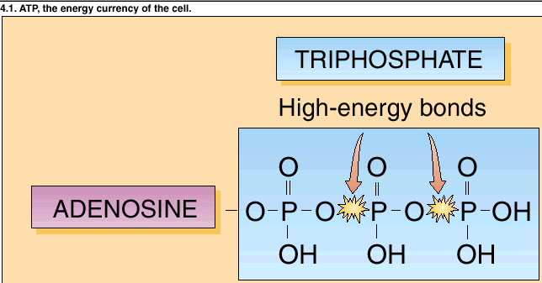
A tight linkage or coupling exists between the breakdown of the macronutrient energy molecules and ATP synthesis, which “captures” a significant portion of the released energy within its bonds. Coupled reactions occur in pairs; the breakdown of one compound provides energy for building another compound. To meet energy needs, ATP joins with water (in a process termed hydrolysis) splitting the outermost phosphate bond from the ATP molecule, forming a new compound adenosine diphosphate or ADP. These reactions, in turn, couple to other reactions that use the “freed” phosphate-bond chemical energy. The body uses ATP to transfer the energy produced during catabolic reactions to power reactions that synthesize new materials. In essence, this energy receiver – energy donor cycle represents the cells' two major energy-transforming activities:
Figure 1. ATP and it’s high energy bonds.
- Form and conserve ATP from food's potential energy
- Use energy extracted from ATP to power biologic work
Figure 2 illustrates examples of the anabolic and catabolic reactions that involve the coupled transfer of chemical energy. All of the energy released from catabolizing one compound does not dissipate as heat; rather, a portion becomes harvested and conserved within the chemical structure of the newly formed compound. ATP represents the common energy transfer “vehicle” in most coupled biologic reactions.
Anabolism requires energy for synthesizing new compounds. For example, several glucose molecules join together, much like the links in a chain of sausages to form the larger more complex glycogen molecule; similarly, glycerol and fatty acids combine to make triglycerides, and amino acids link forming proteins. Each reaction starts with simple compounds and uses them as building blocks to form larger, more complex compounds. Catabolic reactions release energy; in many instances, this process couples to ATP formation.
For each mole of ATP degraded to adenosine diphosphate (ADP), the outermost phosphate bond splits, liberating approximately 7.3 kCal of free energy (i.e., energy available for work).
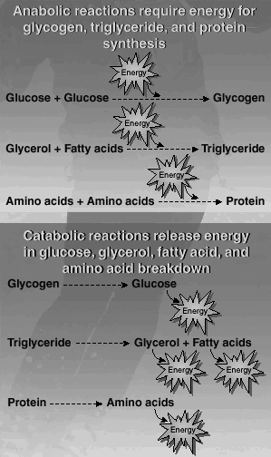
ATP + H₂O ––––>ATP + P (-7.3 kCal)
Figure 2. Examples of anabolic and catabolic reactions that involve coupled energy transfer.
Because this reaction generates considerable energy, ATP is referred to as a high-energy phosphate compound. Additional energy releases when another phosphate splits from ADP. In some reactions of biosynthesis, ATP donates its two terminal phosphates. In this case, adenosine monophosphate (AMP) becomes the new molecule with a single phosphate group.
The energy liberated during ATP breakdown directly transfers to other energy-requiring molecules. In muscle, this energy activates specific sites on the contractile elements causing muscle fibers to shorten. Because energy from ATP powers all forms of biologic work, ATP constitutes the cell’s “energy currency.”
The splitting of an ATP molecule immediately takes place without oxygen. The cell’s capability for ATP breakdown generates energy for rapid use. Think of this anaerobic energy release as a back-up power source, called upon to deliver energy in excess of what can be generated aerobically. For this reason, any form of activity can take place immediately without instantaneously consuming oxygen; examples include sprinting for a bus, lifting a fork, driving a golf ball, spiking a volleyball, doing a pushup, or jumping up in the air. The well known practice of holding one’s breathe while sprint swimming provides a clear example of ATP splitting without reliance on atmospheric oxygen. Withholding air (oxygen), although not advisable, can be done during a 100-yard sprint on the track, lifting a barbell, a dash up several flights of stairs, or simply holding one's breath while rapidly flexing and extending the arms or fingers. In each case, energy metabolism proceeds uninterrupted because the energy for performing the activity comes exclusively from intramuscular anaerobic sources.

ATP Resynthesis
Because cells store only a small quantity of ATP, it must continually be resynthesized at its rate of use. This provides a biologically useful mechanism for regulating energy metabolism. By maintaining only a small amount of ATP, its relative concentration (and corresponding concentration of ADP) changes rapidly with any increase in a cell’s energy demands. An ATP:ADP imbalance at the start of exercise immediately stimulates the breakdown of other stored energy-containing compounds to resynthesize ATP. As one might expect, increases in cellular energy transfer depend on exercise intensity. Energy transfer increases about four-fold in the transition from sitting in a chair to walking. However, changing from a walk to an all-out sprint almost immediately accelerates energy transfer rate about 120 times! Generating significant energy output almost instantaneously demands ATP availability and a means for its rapid resynthesis.

ATP: A Limited Currency
As previously pointed out, a limited quantity of ATP serves as the energy currency for all cells. In fact, at any one time the body stores only about 80 to 100 g (3.5 oz.) of ATP. This provides enough intramuscular stored energy for several seconds of explosive, all-out exercise. A limited quantity of “stored” ATP represents an advantage due to the molecule's heaviness. Biochemists estimate that sedentary persons each day use an amount of ATP approximately equal to 75% of their body mass. For an endurance athlete running a marathon race and generating about 20 times the resting energy expenditure over 3 hours, total ATP usage could amount to 80 kg! Thus, with limited supplies and with high demand, ATP must be continually resynthesized to meet energy requirements.

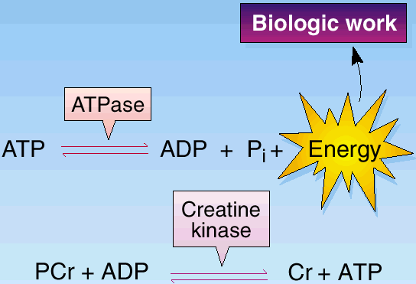
Phosphocreatine (PCr): The Energy Reservoir
Figure 3. ATP and PCr are anaerobic sources of phosphate-bond energy. The energy liberated from the hydrolysis (splitting) of PCr powers the union of ADP to reform ATP.
Some energy for ATP resynthesis comes directly from the splitting (hydrolysis) of a phosphate from another intracellular high-energy phosphate compound – phosphocreatine (PCr), also known as creatine phosphate or CP. PCr, similar to ATP, releases a large amount of energy when the bond splits between the creatine and phosphate molecules. The hydrolysis of PCr for energy begins at the onset of intense exercise, does not require oxygen, and reaches a maximum in about 10 seconds. Thus, PCr can be considered a “reservoir” of high-energy phosphate bonds. Figure 3 illustrates the release and use of phosphate-bond energy in ATP and PCr. The term high-energy phosphates describe these stored intramuscular compounds. ATP and PCr are anaerobic sources of phosphate-bond energy. The energy liberated from the hydrolysis (splitting) of PCr powers the union of ADP and P to reform ATP.
In both reactions in Figure 3, the arrows point in opposite directions to indicate reversible reactions. In other words, creatine (C) and phosphate (P) can join again to reform PCr. This also holds true for ATP where the union of ADP and P reforms ATP (see top part of figure). ATP resynthesis occurs if sufficient energy exists to rejoin an ADP molecule with one P molecule. Hydrolysis of PCr supplies this energy.
Cells store PCr in considerably larger quantities than ATP. Mobilization of CP for energy takes place almost instantaneously and does not require oxygen. For this reason, PCr is considered a “reservoir” of high-energy phosphate bonds.

Cellular Oxidation
A molecule becomes reduced when it accepts electrons from an electron donor. In turn, the molecule that gives up the electron becomes oxidized. Oxidation reactions (donating electrons) and reduction reactions (accepting electrons) remain coupled because every oxidation coincides with a reduction. In essence, cellular oxidation-reduction constitutes the mechanism for energy metabolism. The stored carbohydrate, fat, and protein molecules continually provide hydrogen atoms in this process. The mitochondria, the cell’s “energy factories,” contain carrier molecules that remove electrons from hydrogen (oxidation) and eventually pass them to oxygen (reduction). Synthesis of the high-energy phosphate ATP occurs during oxidation-reduction reactions.

Electron Transport
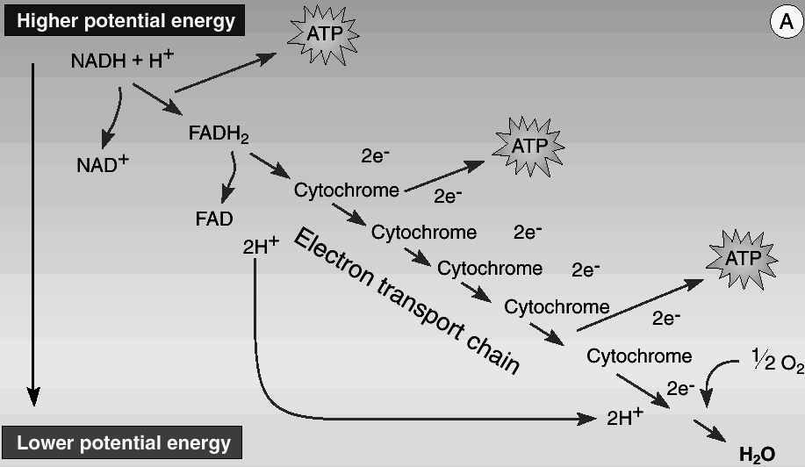
Figure 4 illustrates the general scheme for hydrogen oxidation and accompanying electron transport to oxygen. During cellular oxidation, hydrogen atoms are not merely turned loose in the cell fluid. Rather, highly specific enzymes catalyze hydrogen's release from the nutrient substrate. The coenzyme nicotinamide adenine dinucleotide or NAD⁺ accepts pairs of electrons (energy) from hydrogen. While the substrate oxidizes and loses hydrogen (electrons), NAD⁺ gains a hydrogen and two electrons and reduces to NADH; the other hydrogen appears as H⁺ in the cell fluid.
Figure 4. In the body, the electron transport chain removes electrons from hydrogen and ultimately delivers them to oxygen. In this oxidation-reduction process, much of the chemical energy stored within the hydrogen atoms does not dissipate to kinetic energy, rather, it becomes conserved in forming ATP.
The riboflavin-containing coenzyme, flavin adenine dinucleotide (FAD) serves as the other important electron acceptor in oxidizing food fragments.
The NADH and FADH₂ formed in macronutrient breakdown represent energy-rich molecules because they carry electrons with a high-energy transfer potential. The cytochromes, a series of iron-protein electron carriers, then pass in “bucket brigade” fashion pairs of electrons carried by NADH and FADH₂ on the inner membranes of the mitochondria. Cytochromes transfer electrons to their destination, where they reduce oxygen to form water. The NAD⁺ and FAD then recycle for subsequent energy metabolism.
Electron transport by specific carrier molecules constitutes the respiratory chain, serving as the final common pathway where electrons extracted from hydrogen pass to oxygen. For each pair of hydrogen atoms, two electrons flow down the chain and reduce one atom of oxygen to form water. Of the five specific cytochromes, only the last one, cytochrome oxidase (cytochrome a³ with a strong affinity for oxygen), discharges its electron directly to oxygen.
In the body, the electron-transport chain removes electrons from hydrogen and ultimately delivers them to oxygen. In this oxidation-reduction process, much of the chemical energy stored within the hydrogen atom becomes conserved in forming ATP.

Role of Oxygen in Energy Metabolism
For aerobic metabolism, oxygen serves as the final electron acceptor in the respiratory chain and combines with hydrogen to form water during energy metabolism. Some might argue that the term aerobic metabolism is misleading, since oxygen does not participate directly in ATP synthesis. Oxygen's presence at the “end of the line,” however, largely determines one’s capability for ATP production and, hence, the ability to sustain high-intensity exercise. In this sense, use of the term aerobic seems justified.

Part 2. Energy Release From Food
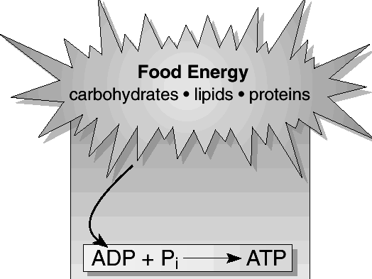
The energy released in macronutrient breakdown serves one crucial purpose – to phosphorylate ADP to reform the energy-rich compound ATP (Figure 5). Although macronutrient catabolism favors generating phosphate-bond energy, the specific pathways of degradation differ depending on the nutrients metabolized.
Figure 5. Potential energy in food powers ATP resynthesis

Energy Release from Carbohydrate
Carbohydrate's primary function supplies energy for cellular work. Carbohydrate represents the only macronutrient whose potential energy can generate ATP anaerobically. This becomes important in vigorous exercise that requires rapid energy release above levels supplied by aerobic metabolic reactions.
- During light and moderate aerobic exercise, carbohydrate supplies about one-half of the body’s energy requirements.
- Processing fat through the metabolic mill for energy requires some carbohydrate catabolism.
- Aerobic breakdown of carbohydrate for energy occurs at about twice the rate as energy generated from fatty acid breakdown. Thus, depleting glycogen reserves significantly reduces exercise power output. In prolonged high-intensity, aerobic exercise such as marathon running, athletes often experience nutrient-related fatigue – a state associated with muscle and liver glycogen depletion.
The complete breakdown of 1 mole of glucose (180 g) to carbon dioxide and water yields 686 kcal of chemical free energy.
C₆H₁₂O₆ + 6O₂ ––––> 6CO₂ + 6H₂O + 689 kCal per mole

Anaerobic versus Aerobic
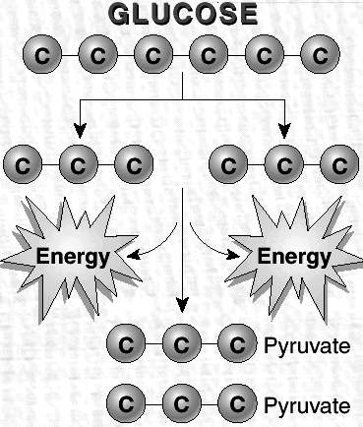
Glucose degradation occurs in two stages. In stage one, glucose breaks down to two molecules of pyruvate. Energy transfers occur without oxygen (anaerobic). In stage two, pyruvate degrades further to CO₂ and H₂O. Energy transfers from these reactions require electron transport and oxidative phosphorylation.
Figure 6. Glycolysis. A 6-carbon glucose splits into two, 3-carbon compounds that degrade into two, 3-carbon pyruvate molecules. Glucose splitting occurs anaerobically.

Anaerobic Energy from Glucose: Glycolysis (Glucose Splitting)
The first stage of glucose degradation within cells involves a series of ten chemical reactions collectively termed glycolysis (also termed the Embden-Meyerhof pathway for its discoverers); glycogenolysis describes these reactions when they begin with stored glycogen. These series of reactions occur in the watery medium of the cell outside of the mitochondrion. In a way, glycolytic reactions represent a more primitive form of energy transfer, well developed in amphibians, reptiles, fish, and marine mammals. In humans, the cells’ limited capacity for glycolysis becomes crucial during activities that require effort for up to 90-sec.
Figure 6 shows the glucose-to-pyruvate sequence under anaerobic conditions in terms of the carbon atoms. The six-carbon glucose splits into two 3-carbon compounds (pyruvate). These subsequently degrade into two molecules of pyruvate with the net release of 2 ATP (i.e., energy).

Formation of Lactic Acid
Sufficient oxygen bathes the cells during light-to-moderate of energy metabolism. The hydrogen (electrons) stripped from the substrate and carried by NADH oxidizes within the mitochondria to form water as they join with oxygen.
In strenuous exercise, when energy demands exceed either oxygen supply or utilization, the respiratory chain cannot process all of the hydrogen joined to NADH. Continued release of anaerobic energy in glycolysis depends on NAD⁺ availability; otherwise, the rapid rate of glycolysis stops. In anaerobic glycolysis, NAD⁺ “frees-up” as pairs of “excess” non-oxidized hydrogen combine temporarily with pyruvate to form lactic acid, catalyzed by the enzyme lactic dehydrogenase (LDH) in the reversible reaction shown in Figure 7.
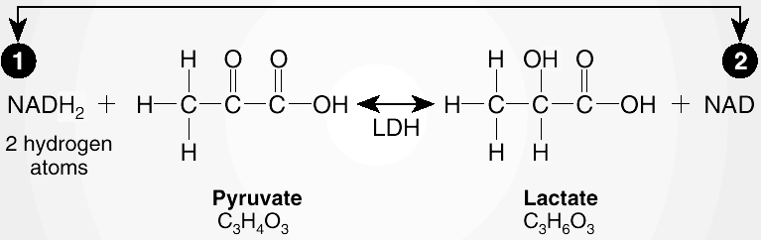
The temporary storage of hydrogen with pyruvate represents a unique aspect of energy metabolism because it provides a ready “storage bin” to temporarily hold the end products of anaerobic glycolysis. Also, once lactic acid forms within muscle, it diffuses rapidly into the blood for buffering to sodium lactate and removal from the site of energy metabolism. This allows glycolysis to continue supplying additional anaerobic energy for ATP resynthesis. However, this avenue for extra energy remains temporary; blood lactate and muscle lactic acid levels increase and ATP regeneration cannot keep pace with its utilization rate. Fatigue soon sets in and exercise performance diminishes.
Figure 7. Lactate forms when excess hydrogen combines with pyruvate.
Even at rest, energy metabolism in red blood cells form some lactic acid. This occurs as the red blood cells contain no mitochondria and must derive their energy from glycolysis. Lactic acid should not be viewed as a metabolic “waste product” as it provides a valuable source of energy that accumulates in the body during heavy exercise. When sufficient oxygen becomes available during recovery, or when exercise pace slows, NAD⁺ scavenges hydrogen attached to lactate; this hydrogen subsequently oxidizes to form ATP. Thus, blood lactate becomes an energy source as it readily reconverts to pyruvate to undergo further catabolism.

Aerobic Energy From Glucose: The Krebs Cycle
The anaerobic reactions of glycolysis release about 10% of the energy within the original glucose; thus, extracting the remaining energy requires additional metabolism. This occurs when pyruvate irreversibly converts to acetyl–CoA. Acetyl–CoA enters the second stage of carbohydrate breakdown known as the Krebs cycle (citric acid cycle). For each molecule of acetyl-CoA entering the Krebs cycle, two CO₂ molecules and 4 pairs of hydrogen atoms release. One molecule of ATP also regenerates directly from the Krebs cycle.
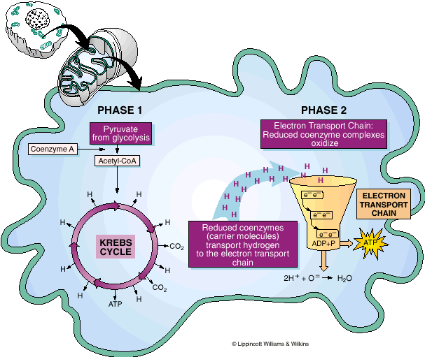
Oxygen does not participate directly in the Krebs cycle. The aerobic process of electron transport-oxidative phosphorylation transfers the major portion of chemical energy in pyruvate to ADP. With adequate oxygen, enzymes and substrate, NAD and FAD regeneration takes place allowing Krebs cycle metabolism to proceed.
Figure 8. Two phases of the Citric Acid cycle. Phase 1 in the mitochondrion, Krebs cycle activity generates hydrogen atoms. Phase 2 – significant ATP regenerates when hydrogen oxidizes via the aerobic process of electron transport.
Figure 8 shows the two phases of Krebs cycle activity. Phase 1 involves the introduction of pyruvate (from glycolysis), combined with coenzyme A (a Vitamin B derivative), into the Krebs cycle with the release of hydrogen, CO₂ and ATP. Phase 2 shows significant ATP regeneration when hydrogen oxidizes via the aerobic process of electron transport-oxidative phosphorylation (electron transport chain).

Net Energy Transfer From Glucose Catabolism
For the complete metabolism of glucose in muscle (anaerobic + aerobic) a total of 36 ATP are formed.: Four ATP form from in glycolysis; and 2 ATP come from acetyl-CoA degradation in Krebs cycle; the Krebs cycle further releases 30 ATP.

Energy Release From Fat
Figure 11
Stored fat represents the body’s most plentiful source of potential energy. Relative to carbohydrate and protein, stored fat provides almost unlimited energy. The actual fuel reserves in an average young adult male represent between 60,000 and 100,000 kcal of energy from triglyceride in fat cells (adipocytes), and about 3000 kcal from intramuscular triglyceride stored in close proximity to the mitochondria. In contrast, the carbohydrate energy reserve would only contribute about 2000 kcal. Prior to energy release from fat, lipolysis splits the triglyceride molecule into glycerol and three water-insoluble fatty acid molecules. The enzyme lipase catalyzes triglyceride breakdown as follows:
Triglyceride + 3H₂O ––––––> Glycerol + 3 Fatty acids

Breakdown of Glycerol and Fatty Acids

Glycerol
The anaerobic reactions of glycolysis accept glycerol as 3-phosphoglyceraldehyde, which then degrades to pyruvate to form ATP by substrate-level phosphorylation. Hydrogen atoms pass to NAD⁺, and the Krebs cycle oxidizes pyruvate. The complete breakdown of the single glycerol molecule in a triglyceride synthesizes a total of 19 ATP molecules. Glycerol also provides carbon skeletons for glucose synthesis. The gluconeogenic role of glycerol becomes prominent when glycogen reserves deplete due to dietary restriction of carbohydrates, or in long-term exercise or heavy training.

Fatty Acids
For Your Information
Intensity and Duration Affect Fat Use
Fatty acid oxidation occurs during low intensity exercise. For example, fat combustion almost totally powers exercise at 25% of aerobic capacity. Carbohydrate and fat contribute energy equally during moderate exercise. Fat oxidation gradually increases as exercise extends to an hour or more and carbohydrates become depleted. Toward the end of prolonged exercise (with glycogen reserves low), circulating FFAs supply nearly 80% of the total energy required.
The fatty acid molecule transforms to acetyl-CoA in the mitochondrion during beta–oxidation reactions. This involves the successive release of 2-carbon acetyl fragments split from the fatty acid's long chain. ATP phosphorylates the reactions, water is added, and hydrogen pass to NAD+ and FAD, and acetyl–CoA forms when the acetyl fragment joins with coenzyme A. This acetyl unit is the same one generated from glucose breakdown. Beta-oxidation continues until the entire fatty acid molecule degrades to acetyl–CoA so it can directly enter the Krebs cycle. Hydrogen released during fatty acid catabolism oxidizes through the respiratory chain. Note that fatty acid breakdown relates directly with oxygen uptake. For beta–oxidation to proceed, oxygen must be present to join with hydrogen. Without oxygen (anaerobic conditions), hydrogen remains joined with NAD⁺ and FAD bringing fat catabolism to a halt.

Total Energy Transfer From Fat Catabolism
For each 18-carbon fatty acid molecule, 147 molecules of ADP phosphorylate to ATP during beta-oxidation and Krebs cycle metabolism. Because each triglyceride molecule contains three fatty acid molecules, 441 ATP molecules form from the triglyceride's fatty acid components (3 x 147 ATP). Also, 19 molecules of ATP form during glycerol breakdown, generating a total of 460 molecules of ATP for each triglyceride molecule catabolized. This represents a considerable energy yield because only a net of 36 ATP form during a glucose molecule's catabolism in skeletal muscle. The 40% efficiency of energy conservation for fatty acid oxidation amounts to a value similar to glucose oxidation efficiency.
Energy Release From Protein
Protein plays a contributory role as an energy substrate during endurance-type activities. The amino acids (primarily the branched-chain amino acids leucine, isoleucine, valine, glutamine, and aspartate) first must convert to a form that readily enters pathways for energy release. This conversion requires removing nitrogen from the amino acid molecule. In this way, the muscle can directly use for energy the “carbon skeleton” by-products of donor amino acids. Only when an amino acid loses its nitrogen containing amino group can the remaining compound (usually one of the Krebs cycle's reactive compounds) contribute to ATP formation. Some amino acids are glucogenic; they yield intermediate products for glucose synthesis via gluconeogenesis. This gluconeogenic method serves as an important adjunct to provide glucose during prolonged exercise.

The Metabolic Mill
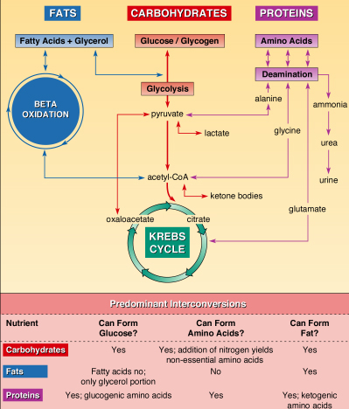
The “metabolic mill” (Figure 9 below) depicts the Krebs cycle as the essential "connector" between energy from food macronutrients energy and chemical energy of ATP. The Krebs cycle also serves as a metabolic hub to provide intermediates to synthesize bionutrients for maintenance and growth. For example, excess carbohydrates provide the glycerol and acetyl fragments to synthesize triglyceride. Acetyl–CoA also functions as the starting point for synthesizing cholesterol and many hormones. In contrast, fatty acids do not contribute to glucose synthesis because pyruvate's conversion to acetyl-CoA does not reverse (notice the one-way arrow in Figure 12). Many of the carbon compounds generated in Krebs cycle reactions also provide the organic starting points for synthesizing nonessential amino acids. Amino acids, particularly alanine with carbon skeletons resembling Krebs cycle intermediates after deamination becomes synthesized to glucose.

