Name: __________________________
Section: _________________________
DESCRIPTION
- Look at and handle the object for a short time, then write a brief description of the object and its decoration – what do you think are its most important characteristics?

2. How would you describe this object’s state of preservation? Do you think anything might be missing, or is it whole and intact?

3. (a) Carefully use the calipers to determine the height, width, and thickness of this object in centimeters.

Width: Height: Thickness:

(b) Use your measurements and observations to draw a rough sketch of the object here:

Side/Profile Front

PRODUCTION
4. How and from which materials was this object made? Refer to the list of production techniques attached to this worksheet.

5. Do you think that this object was relatively expensive or inexpensive? Why?

FUNCTION AND CONTEXT
6. What is the function of light in the following passage from Qur’an 24:35?

“God is the light of the Heavens and the Earth. His Light is like a niche in which is a lamp - the lamp enclosed in glass - the glass, as it were, a glistening star. From a blessed tree it is lighted, the olive neither of the East nor of the West, whose oil would well neigh shine out, even though fire touched it not! It is light upon light. God guideth whom He will to His light, and God setteth forth parables to men, for God knoweth.”

7. How is your object similar or dissimilar to an incandescent light bulb? Consider the expense of a lightbulb for the consumer relative to its power-source, and the ways in which governments today intervene to maintain energy supplies for consumers.
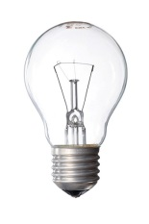

SIGNIFICANCE
8. Our modern conceptions of pornography or illicit sexual behavior were not shared with ancient Romans. Frescoes or paintings of sex acts were common decorations in the homes of middle- or upper-class Romans.

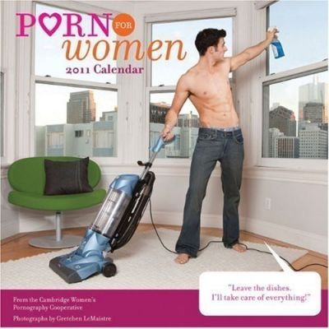

Consider carefully the following image above. In 1964, US Supreme Court Justice Potter Stewart famously said of pornography that, “I know it when I see it.”

What is the difference between the representation on your object and the image above? Why might the image above be called “porn for women”? But what makes an image pornographic?

9. If you took your object out of the museum and put it back in the ancient world, where and with whom would you put it, and why? How were ancient people using this object?

Production Methods

Ceramics
  - Wheel-made ceramic objects were made on a potter’s wheel: this is a flat disk on which clay was placed that was spun at high speed. The potter used their hands or instruments to shape the clay as it turned. Afterwards hundreds to thousands of objects were placed in a kiln and fired until hard. Because these objects are turned on a potter’s wheel, they are circular on one axis and symmetrical about a center point (think of a plate or bowl). They usually have ridge lines from the vessel spinning in the potter’s hands.
  - Mould-made ceramics were created by first carving a mould in two pieces of stone (one for the top, one for the bottom). Clay was pressed into each half of the mould, the two halves were pressed together and the whole thing was fired in a kiln until hard. The result was an object of almost any shape (as opposed to the wheel-made ceramics, which must be circular on one axis), often with intricate “carved” designs. You can often see a line where the two mould halves came together.

Metal
  - Casting was a technique similar to mould-made ceramics (above), but whereas clay is pressed into a mould, molten metal or glass is poured into a cast.
  - Lost-wax (or lost-mould) casting was a technique for casting objects in which the artist created an object’s model from hard wax (or another material with a low melting-point temperature). Clay was then shaped around the wax model, forming a soft interior and a hard exterior. A hole was pierced through the hard exterior into the wax and the mould was fired until hard, thereby also melting and draining the wax. Molten metal was poured into the empty exterior mould and allowed to cool, before the mould was broken to reveal the now-hardened metal version of the wax model.

Glass
  - Cast glass: see above under “casting”.
  - Blown glass was created using a technique in which molten glass was placed on the end of a tube that the glassblower would then blow through. The result was any roundish object that was hollow.
  - Core-formed glass vessels were created by first creating the shape of the intended object out of clay (the core) and then heating it and rolling it in powdered glass, which built up around the core. Bands of colored glass were then applied and pressed into the powdered glass. Designs were then made with tools and handles were attached (if the vessel had handles). The core was then removed, resulting in a glass vessel with geometric designs on the outside.

Lots of Materials
  - Carving a negative process, whereby different instruments (blades, chisels, etc.) are used to remove material from a larger block in order to create a desired shape.

