Name: __________________________
Section: _________________________
DESCRIPTION
- Look at and handle the object for a short time, then write a brief description of the object – what do you think are its most important characteristics?

2. How would you describe this object’s state of preservation? Do you think anything might be missing, or is it whole and intact?

3. (a) Carefully use the calipers to determine the height, width, and thickness of this object in centimeters.

Diameter at top: Diameter at bottom: Height:

3. (b) Use your measurements and observations to draw a rough sketch of the object here:

Side/Profile Top-Down

PRODUCTION
4. From which materials and how do you think this object was made? Would you have used different tools to make the object or its decoration? Refer to the list of production methods attached to this worksheet.

FUNCTION AND CONTEXT

5. Read this poem by the Roman poet Ovid, from the late 1st century BCE.

Vetches, and beaten barley, let ‘em take,
And with the whites of eggs a mixture make;
Then dry the precious paste with sun and wind
And into powder very gently grind.
Get hart’s-horn next (but let it be the first
That creature sheds), and beat it well to dust.
Six pound in all; then mix and sift ‘em well,
And think the while how fond Narcissus fell;
Six roots to you that pensive flower must yield
To mingle with the rest, well bruis'd and cleanly pill’d.
Two ounces next of gum, and thural seed,
That for the gracious gods does incense breed,
And let a double share of honey last succeed.
With this whatever damsel paints her face,
Will need no flattering glass to show a grace.

How could your object assist in the procedure described here?

6. Below is a close-up of the bust of Nefertiti, One of the most famous portraits of the ancient world (c. 1345 BCE). Which kinds of make-up is she wearing, and how might they have embellished her appearance? Do you think she would be considered beautiful today? Why or why not?

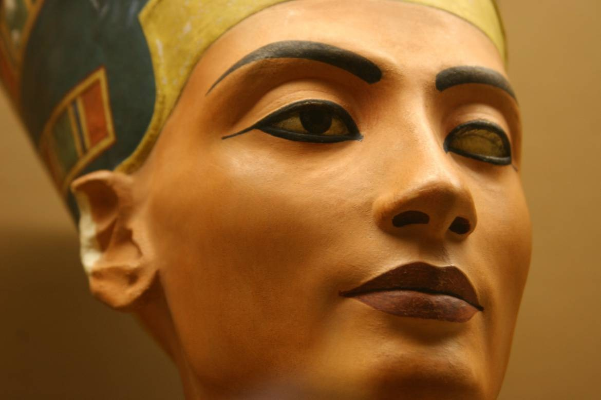

SIGNIFICANCE
7. Below is the image of a Maybelline makeup advertisement from the 1920s. Cosmetics are as old as vanity (that is, they’re very ancient!), but the ways in which they are made and applied have changed dramatically throughout time. Comparing your object and the ad with its text below, could you explain how makeup contributes to the conception of beauty or gender-identity throughout time? Can you find a makeup accessory in this ad that might be analogous to your object?

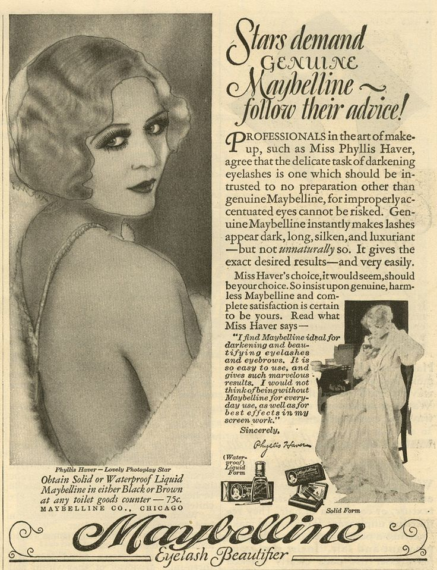

8. If you took your object out of the museum and put it back in the ancient world, where and with whom would you put it, and why?

Production Methods

Ceramics
  - Wheel-made ceramic objects were made on a potter’s wheel: this is a flat disk on which clay was placed that was spun at high speed. The potter used their hands or instruments to shape the clay as it turned. Afterwards hundreds to thousands of objects were placed in a kiln and fired until hard. Because these objects are turned on a potter’s wheel, they are circular on one axis and symmetrical about a center point (think of a plate or bowl). They usually have ridge lines from the vessel spinning in the potter’s hands.
  - Mould-made ceramics were created by first carving a mould in two pieces of stone (one for the top, one for the bottom). Clay was pressed into each half of the mould, the two halves were pressed together and the whole thing was fired in a kiln until hard. The result was an object of almost any shape (as opposed to the wheel-made ceramics, which must be circular on one axis), often with intricate “carved” designs. You can often see a line where the two mould halves came together.

Metal
  - Casting was a technique similar to mould-made ceramics (above), but whereas clay is pressed into a mould, molten metal or glass is poured into a cast.
  - Lost-wax (or lost-mould) casting was a technique for casting objects in which the artist created an object’s model from hard wax (or another material with a low melting-point temperature). Clay was then shaped around the wax model, forming a soft interior and a hard exterior. A hole was pierced through the hard exterior into the wax and the mould was fired until hard, thereby also melting and draining the wax. Molten metal was poured into the empty exterior mould and allowed to cool, before the mould was broken to reveal the now-hardened metal version of the wax model.

Glass
  - Cast glass: see above under “casting”.
  - Blown glass was created using a technique in which molten glass was placed on the end of a tube that the glassblower would then blow through. The result was any roundish object that was hollow.
  - Core-formed glass vessels were created by first creating the shape of the intended object out of clay (the core) and then heating it and rolling it in powdered glass, which built up around the core. Bands of colored glass were then applied and pressed into the powdered glass. Designs were then made with tools and handles were attached (if the vessel had handles). The core was then removed, resulting in a glass vessel with geometric designs on the outside.

Lots of Materials
  - Carving a negative process, whereby different instruments (blades, chisels, etc.) are used to remove material from a larger block in order to create a desired shape.

