Name: __________________________
Section: _________________________
DESCRIPTION
- Look at and handle the object for a short time – with and without the magnifying glass -- then write a brief description of the object and the art depicted on it. What do you think are the most important characteristics of this object?

2. How would you describe this object’s state of preservation? Do you think anything might be missing, or is it whole and intact?

3. (a) Carefully use the calipers to determine the height, width, and thickness of this object in centimeters.

Max Width: Max Length: Blade Thickness:

3. (b) Use your measurements and observations to draw a rough sketch of the object here:

Side/Profile Front

PRODUCTION
4. (a) Does this object have symmetry on one or more dimensions? (b) Do the physical features of this object give clues about how it was made? Consider the list of production methods attached to this worksheet.

5. Was this object expensive or inexpensive? Why?

FUNCTION AND CONTEXT
6. (a) What do you and your partner think that this object was? What do you think that it was used for?

(b) Objects like yours are usually found in burials, often accompanied by arrow-heads or blades, in addition to pottery and jewelry. Brainstorm explanations for these facts. What do they tell us about the people who may have used this ax?

(c) Look carefully at the figures that inhabit the sides of your object – how could these figures be related to the object’s function?

SIGNIFICANCE

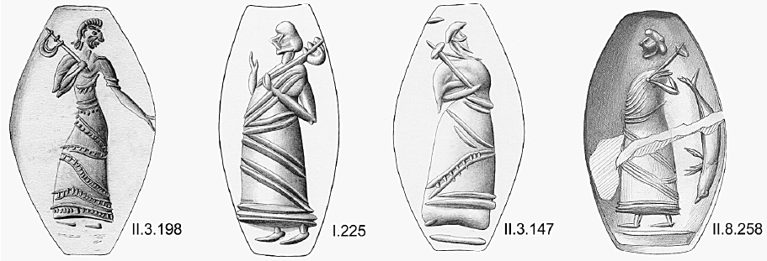

7. (a) Represented above are Mycenaean seal-stones made in Crete c. 1500 BCE. Seal-stones were used to stamp wax with an individual’s personal mark or image, akin to a signature. These seal-stones depict ‘dignitaries’ carrying your object. Why would an individual choose to be represented in this fashion? What do these representations tell you about the role of your object for ancient people?

(b) If you created a seal with an image to identify yourself, what would you put on it?

8. If you took this object out of the museum and put it back in the ancient world, where and with whom would you put it, and why?

Production Methods

Ceramics
  - Wheel-made ceramic objects were made on a potter’s wheel: this is a flat disk on which clay was placed that was spun at high speed. The potter used their hands or instruments to shape the clay as it turned. Afterwards hundreds to thousands of objects were placed in a kiln and fired until hard. Because these objects are turned on a potter’s wheel, they are circular on one axis and symmetrical about a center point (think of a plate or bowl). They usually have ridge lines from the vessel spinning in the potter’s hands.
  - Mould-made ceramics were created by first carving a mould in two pieces of stone (one for the top, one for the bottom). Clay was pressed into each half of the mould, the two halves were pressed together and the whole thing was fired in a kiln until hard. The result was an object of almost any shape (as opposed to the wheel-made ceramics, which must be circular on one axis), often with intricate “carved” designs. You can often see a line where the two mould halves came together.

Metal
  - Casting was a technique similar to mould-made ceramics (above), but whereas clay is pressed into a mould, molten metal or glass is poured into a cast.
  - Lost-wax (or lost-mould) casting was a technique for casting objects in which the artist created an object’s model from hard wax (or another material with a low melting-point temperature). Clay was then shaped around the wax model, forming a soft interior and a hard exterior. A hole was pierced through the hard exterior into the wax and the mould was fired until hard, thereby also melting and draining the wax. Molten metal was poured into the empty exterior mould and allowed to cool, before the mould was broken to reveal the now-hardened metal version of the wax model.

Glass
  - Cast glass: see above under “casting”.
  - Blown glass was created using a technique in which molten glass was placed on the end of a tube that the glassblower would then blow through. The result was any roundish object that was hollow.
  - Core-formed glass vessels were created by first creating the shape of the intended object out of clay (the core) and then heating it and rolling it in powdered glass, which built up around the core. Bands of colored glass were then applied and pressed into the powdered glass. Designs were then made with tools and handles were attached (if the vessel had handles). The core was then removed, resulting in a glass vessel with geometric designs on the outside.

Lots of Materials
  - Carving a negative process, whereby different instruments (blades, chisels, etc.) are used to remove material from a larger block in order to create a desired shape.

