Name: __________________________
Section: _________________________
DESCRIPTION
- Look at and handle the object for a few minutes, then write a description of the object. What are its most salient or important features?

- (a) How would you describe this object’s state of preservation? Is it intact? Is anything missing? Use your magnifying glass – do you see anything different?

(b) Carefully use the ruler and calipers to determine the height, width, and thickness of this object in centimeters.

Max. Width: Length: Max. Thickness:
Diameter of roundels:

- Use your measurements and observations to draw a rough sketch of the object here:

PRODUCTION
- Do the physical features of this object give clues about how it was made, or how it was used? Consider the list of production methods attached to this worksheet. Do you think this was an expensive or inexpensive object?

FUNCTION AND CONTEXT
5.
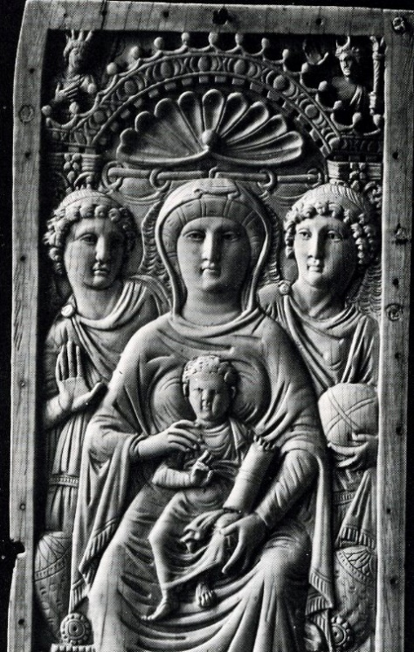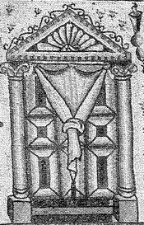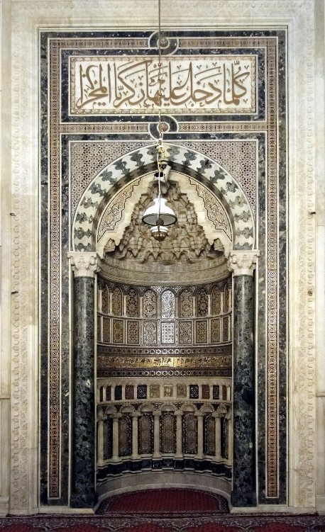
(a) (b) (c)

(a) Byzantine icon on ivory, Virgin and Child. From Constantinople, 6th century CE.
(b) Torah shrine on mosaic. From Synagogue B at Tiberias on the Galilee in Palestine, 5th century CE.
(c) Early Islamic mihrab niche. From the Great Mosque at Damascus, 8th century CE.
Compare these three photographs with your object. Offer two similarities and two differences. What is the function of the frame?

SIGNIFICANCE

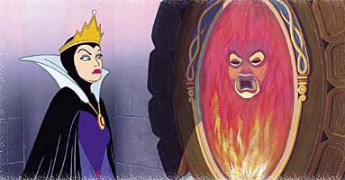

7. A masked face appeared and spoke to the witch in Snow White after she incanted “Mirror, mirror, on the wall, who’s the fairest of them all?” How would you explain what was the witch doing when she spoke to the mirror? Can mirrors – legendarily, in another culture, or in your own experience, perhaps -- show us anything besides our own reflections? Can the experience of looking in a mirror ever be unsettling or cause for anxiety?

Hint: what does the word ‘catoptromancy’ mean?

