Name: __________________________

Section: _________________________

**DESCRIPTION**

1. Look at and handle the object for a short time, using the magnifying glass, then write a concise but detailed description of the object – what do you think are its most important characteristics?

2. How would you describe this object’s state of preservation? Do you think anything might be missing, or is it whole and intact?

3. (a) Carefully use the calipers to determine the height, width, and thickness of this object in centimeters.

Diameter: Thickness: Weight (grams):

3. (b) Use your measurements and observations to draw a **rough** sketch of the object here:

**Front (obverse) Front (reverse)**

**PRODUCTION**

4. What kind of metal or metal alloy was used to make this coin? How can you tell?

5. By which method(s) was this coin made? Use the magnifying glass, and consider the list of production methods attached to this worksheet. [Hint: why is the image of a male bust off-center?]

**FUNCTION AND CONTEXT**

6. (a) Do you think your coin was low or high in exchange value? Why? For which kinds of transactions are high and low value coins useful?

(b) Refer to the translation of the Greek text on this coin; what do you think was its purpose?

(c) Until the abolition of the gold standard by Richard Nixon in 1971, American coins were linked to a standardized value in gold. Ancient coins functioned by the same principle in theory. Imagine that you lived in a historical society accustomed to bartering, at the very moment that coinage was introduced as a form of currency: how would coins change your ability to work or engage in daily commerce?

**SIGNIFICANCE**

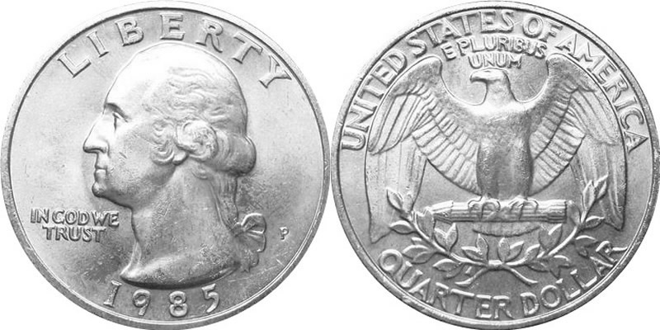

7. Coins are not only currency; they’re also a form of mass communication. Compare your coin with an American quarter. How are they similar or different? Explain the symbols, images, and texts of the American quarter using your ancient coin as a point of comparison.

8. If you took this object out of the museum and put it back in the ancient world, where and with whom would you put it, and why?

**Key for Translation**

**ΑΝΤΙΟΧΟΥ -** *Antiochus*

**ΒΑΣΙΛΕΩΣ -** *king*

**ΕΠΙΦΑΝΟΥΣ -** *manifest*or *revealed*

**ΘΕΟΥ -** *god*

**Production Methods**

Ceramics

* 1. Wheel-made ceramic objects were made on a potter’s wheel: this is a flat disk on which clay was placed that was spun at high speed. The potter used their hands or instruments to shape the clay as it turned. Afterwards hundreds to thousands of objects were placed in a kiln and fired until hard. Because these objects are turned on a potter’s wheel, they are circular on one axis and symmetrical about a center point (think of a plate or bowl). They usually have ridge lines from the vessel spinning in the potter’s hands.
  2. Mould-made ceramics were created by first carving a mould in two pieces of stone (one for the top, one for the bottom). Clay was pressed into each half of the mould, the two halves were pressed together and the whole thing was fired in a kiln until hard. The result was an object of almost any shape (as opposed to the wheel-made ceramics, which must be circular on one axis), often with intricate “carved” designs. You can often see a line where the two mould halves came together.

Metal

* 1. Casting was a technique similar to mould-made ceramics (above), but whereas clay is pressed into a mould, molten metal or glass is poured into a cast.
  2. Lost-wax (or lost-mould) casting was a technique for casting objects in which the artist created an object’s model from hard wax (or another material with a low melting-point temperature). Clay was then shaped around the wax model, forming a soft interior and a hard exterior. A hole was pierced through the hard exterior into the wax and the mould was fired until hard, thereby also melting and draining the wax. Molten metal was poured into the empty exterior mould and allowed to cool, before the mould was broken to reveal the now-hardened metal version of the wax model.

e. Striking / struck metals were produced by placing a blank strip of metal into a die or mould, engraved with an image, and then striking the blank + mould with a hammer to produce an impression on one or two sides

Glass

f. Cast glass: see above under “casting”.

g. Blown glass was created using a technique in which molten glass was placed on the end of a tube that the glassblower would then blow through. The result was any roundish object that was hollow.

h. Core-formed glass vessels were created by first creating the shape of the intended object out of clay (the core) and then heating it and rolling it in powdered glass, which built up around the core. Bands of colored glass were then applied and pressed into the powdered glass. Designs were then made with tools and handles were attached (if the vessel had handles). The core was then removed, resulting in a glass vessel with geometric designs on the outside.

Lots of Materials

i. Carving a negative process, whereby different instruments (blades, chisels, etc.) are used to remove material from a larger block in order to create a desired shape.