Name: __________________________
Section: _________________________
DESCRIPTION
- Look at and handle the object for a short time, then write a brief description of the object – what do you think are its most important characteristics?

2. How would you describe this object’s state of preservation? Do you think anything might be missing, or is it whole and intact?

3. (a) Carefully use the calipers to determine the height, width, and thickness of this object in centimeters.

Diam of base: Diam of middle: Diam at neck:
Height of whole vessel: Height below handle:
Volume estimate [cylinder v = π r² h] :

3. (b) Use your measurements and observations to draw a rough sketch of the object here:

Side/Profile Front

PRODUCTION
4. From which materials and how do you think this object was made? Can you discern separate steps or techniques which may have joined together to create this object? Refer to the list of production methods attached to this worksheet.

5. Do you think this object was expensive or inexpensive? Do you think that this vessel’s contents were more valuable than the container, or vice versa?

FUNCTION AND CONTEXT

6. (a) Look closely at the painted figures on your object. Explain who and what you think is represented here. Where do you think this scene might take place? How are the figures differentiated, and what are they holding?

6. (b) The ancient Greek playwright Eubolus describes drinking at symposia, or banquets, as follows in his play Dionysus (c. 375 BCE):

“For sensible men I prepare only three kraters: one for health (which they drink first), the second for love and pleasure, and the third for sleep. After the third one is drained, wise men go home. The fourth krater is not mine any more - it belongs to bad behaviour; the fifth is for shouting; the sixth is for rudeness and insults; the seventh is for fights; the eighth is for breaking the furniture; the ninth is for depression; the tenth is for madness and unconsciousness.”

What does this passage suggest about Greek ideas of consumption and moderation at banquets?

SIGNIFICANCE

7. The following text comes from a tablet inscribed in the ancient language Linear B, found at Pylos in Greece. Your object was used in conjunction with the process described.

“Thus Alxoitas gave to Thyestes the perfume boiler aromatics for perfume destined for boiling:
Coriander 576 l. Cyperus [an astringent wood, like balsam] 576 l.
Fruits 240 l. Wine 576 l.
Wool 6kg. Honey 58 l.”

What does this text describe, and how could it be related to your object or the Greek institution of symposia?

8. The world – ancient or modern – is a smelly place. The perception of good and bad smells is deeply cultural, because odors are highly associative. We invest smells with meanings, metaphors, and emotions that reveal our social values and norms.

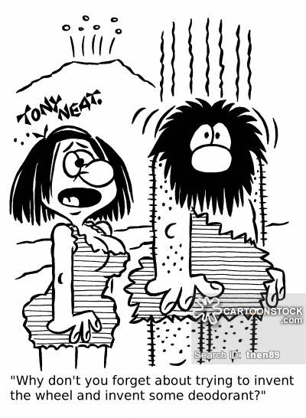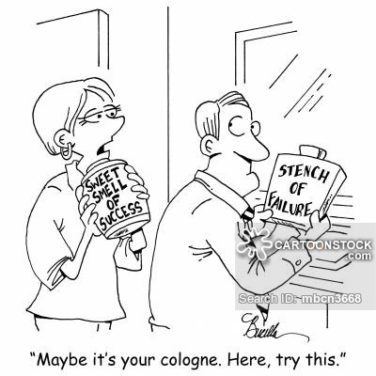

Perfume was invented c. 2000 BCE, but has only been mass produced and widely accessible to consumers at low cost since the 1920s. Imagine that you are a person living in the ancient Mediterranean: which smells would you like? What would you associate them with? Which smells would you detest, but perhaps encounter more frequently than you would like?

9. If you took your object out of the museum and put it back in the ancient world, where and with whom would you put it, and why? How were ancient people using this object?

Production Methods

Ceramics
  - Wheel-made ceramic objects were made on a potter’s wheel: this is a flat disk on which clay was placed that was spun at high speed. The potter used their hands or instruments to shape the clay as it turned. Afterwards hundreds to thousands of objects were placed in a kiln and fired until hard. Because these objects are turned on a potter’s wheel, they are circular on one axis and symmetrical about a center point (think of a plate or bowl). They usually have ridge lines from the vessel spinning in the potter’s hands.
  - Mould-made ceramics were created by first carving a mould in two pieces of stone (one for the top, one for the bottom). Clay was pressed into each half of the mould, the two halves were pressed together and the whole thing was fired in a kiln until hard. The result was an object of almost any shape (as opposed to the wheel-made ceramics, which must be circular on one axis), often with intricate “carved” designs. You can often see a line where the two mould halves came together.

Metal
  - Casting was a technique similar to mould-made ceramics (above), but whereas clay is pressed into a mould, molten metal or glass is poured into a cast.
  - Lost-wax (or lost-mould) casting was a technique for casting objects in which the artist created an object’s model from hard wax (or another material with a low melting-point temperature). Clay was then shaped around the wax model, forming a soft interior and a hard exterior. A hole was pierced through the hard exterior into the wax and the mould was fired until hard, thereby also melting and draining the wax. Molten metal was poured into the empty exterior mould and allowed to cool, before the mould was broken to reveal the now-hardened metal version of the wax model.

Glass
  - Cast glass: see above under “casting”.
  - Blown glass was created using a technique in which molten glass was placed on the end of a tube that the glassblower would then blow through. The result was any roundish object that was hollow.
  - Core-formed glass vessels were created by first creating the shape of the intended object out of clay (the core) and then heating it and rolling it in powdered glass, which built up around the core. Bands of colored glass were then applied and pressed into the powdered glass. Designs were then made with tools and handles were attached (if the vessel had handles). The core was then removed, resulting in a glass vessel with geometric designs on the outside.

Lots of Materials
  - Carving a negative process, whereby different instruments (blades, chisels, etc.) are used to remove material from a larger block in order to create a desired shape.

