Name: __________________________
Section: _________________________
DESCRIPTION
- Look at and handle the object for a short time, then write a brief description of the object – what do you think are its most important characteristics?

2. How would you describe this object’s state of preservation? Do you think anything might be missing, or is it whole and intact?

3. (a) Carefully use the calipers to determine the height, width, and thickness of this object in centimeters.

Width: Height: Wall Thickness:
Interior volume:

3. (b) Use your measurements and observations to draw a rough sketch of the object here:

Side/Profile Front

PRODUCTION
4. Very gently try to raise this object from the table, if only by an inch or two. What material is this object made from? Do the physical features of this object give clues about how it was made? Consider the list of production methods attached to this worksheet.

5. Do you think that this object was expensive or inexpensive? Who might have owned it, and how do you think they came to acquire it?

FUNCTION AND CONTEXT

6. (a) What do you think was the function of this object? Brainstorm several interpretations.

6. (b) Read the following passages from the Ebel Rabbati tractate in the Babylonian Talmud (8th century CE but reflecting much older traditions). Explain what’s being described, and how it might relate to your object.
The bones and the veins must not be taken apart when gathering them; it must not be feared, however, that this will happen while gathering them. All bones one may handle while gathering, except that of his parents, which must be handled by others. Such is the decree of Rabbi Johanan ben Nuri; Rabbi Aqiba, however, said: As the bones are not allowed to be gathered till the flesh is all destroyed, and the form is not recognized any longer, it does not matter even if they are his parents'.

Said Rabbi Eliezer ben Zadok: So my father commanded me: When I will die, you shall first bury me in a valley, then gather my bones, and put them in a cedar casket; but you shall not handle them yourself, and so I did. Johanan entered the grave and gathered (the bones) and spread over them a chest protector, and then I entered, rent my garments over them, and covered them with a sheet. I did to my father as he has done to his.

SIGNIFICANCE

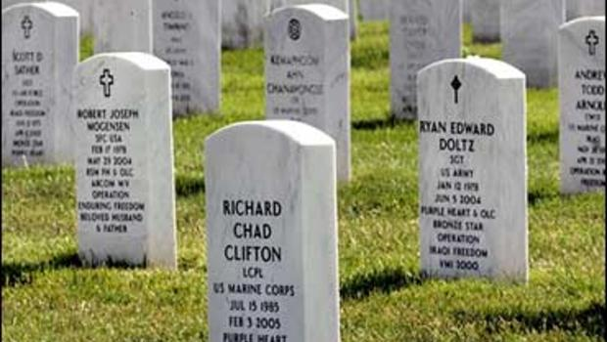

7. Modern cemeteries often contain multitudes of grave markers with the same shape and form; how are similar grave markers distinguished from one another by families of the deceased when they visit a cemetery? What motivates individuals to use grave markers that look share so many similarities?

8. If you took your object out of the museum and put it back in the ancient world, where and with whom would you put it, and why? How were ancient people using this object?

Production Methods

Ceramics
  - Wheel-made ceramic objects were made on a potter’s wheel: this is a flat disk on which clay was placed that was spun at high speed. The potter used their hands or instruments to shape the clay as it turned. Afterwards hundreds to thousands of objects were placed in a kiln and fired until hard. Because these objects are turned on a potter’s wheel, they are circular on one axis and symmetrical about a center point (think of a plate or bowl). They usually have ridge lines from the vessel spinning in the potter’s hands.
  - Mould-made ceramics were created by first carving a mould in two pieces of stone (one for the top, one for the bottom). Clay was pressed into each half of the mould, the two halves were pressed together and the whole thing was fired in a kiln until hard. The result was an object of almost any shape (as opposed to the wheel-made ceramics, which must be circular on one axis), often with intricate “carved” designs. You can often see a line where the two mould halves came together.

Metal
  - Casting was a technique similar to mould-made ceramics (above), but whereas clay is pressed into a mould, molten metal or glass is poured into a cast.
  - Lost-wax (or lost-mould) casting was a technique for casting objects in which the artist created an object’s model from hard wax (or another material with a low melting-point temperature). Clay was then shaped around the wax model, forming a soft interior and a hard exterior. A hole was pierced through the hard exterior into the wax and the mould was fired until hard, thereby also melting and draining the wax. Molten metal was poured into the empty exterior mould and allowed to cool, before the mould was broken to reveal the now-hardened metal version of the wax model.

Glass
  - Cast glass: see above under “casting”.
  - Blown glass was created using a technique in which molten glass was placed on the end of a tube that the glassblower would then blow through. The result was any roundish object that was hollow.
  - Core-formed glass vessels were created by first creating the shape of the intended object out of clay (the core) and then heating it and rolling it in powdered glass, which built up around the core. Bands of colored glass were then applied and pressed into the powdered glass. Designs were then made with tools and handles were attached (if the vessel had handles). The core was then removed, resulting in a glass vessel with geometric designs on the outside.

Lots of Materials
  - Carving a negative process, whereby different instruments (blades, chisels, etc.) are used to remove material from a larger block in order to create a desired shape.

