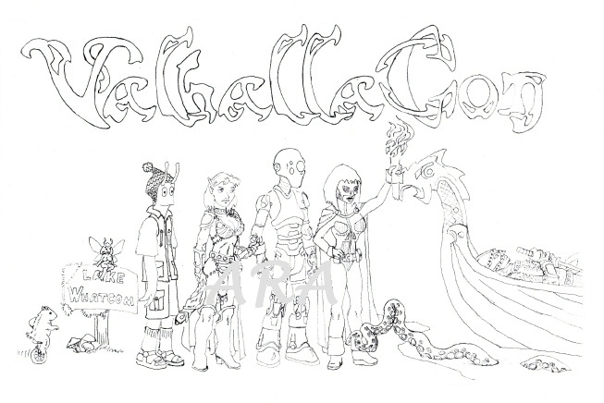

Fictional Linguistics
John Lawler
Professor Emeritus, Linguistics
University of Michigan, Ann Arbor
http://www.umich.edu/~jlawler/NorWesConPanel-1.pdf
NorWesCon 33 2010

Language in Science Fiction
http://xkcd.com/483 The Language Construction Kit

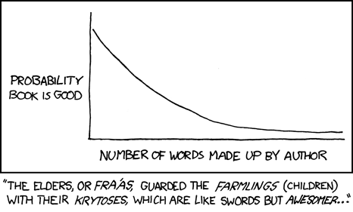
Online: http://www.zompist.com/kit.html
For a number of years, Mark Rosenfelder has maintained a lovely conlang web site with The Language Construction Kit, a small but crisp intro to linguistics for authors who want their linguistic science fiction to be scientific. I once said on the Web that it “contains all the information any SF writer would need to make up a reasonable alien language. And serves as quite a good introduction to linguistic concepts for beginners, to boot.”
As of yesterday, April Fools’ Day 2010, The Language Construction Kit is also a book by Mark Rosenfelder, available from Amazon. It’s much bigger and more inclusive than the online version. I’ve copied, by permission, some relevant pages from it (which do not appear online) into the handout. [Truth in Fictional Linguistics Dept: He asked me to blurb the book.]
http://www.wired.com/geekdad/2009/08/top-ten-geekiest-constructe-languages

The Cambridge Encyclopedia of Language, The Cambridge Encyclopedia of the English Language
(Both by David Crystal, each 1-vol pb. Contain everything one needs to know about the subjects.)

Blogs: Language Log, Tenser, said the Tensor, Language Hat, Arnold Zwicky

The LINGUIST List and the Ethnologue are the best general online linguistic resources to start with

Linguistics in Science Fiction
Suzette Haden Elgin: Linguist and SF writer (Native Tongue, Ozark trilogy, Coyote Jones series)
Publishes a newsletter about Linguistics in/and SF. Check out “We Have Always Spoken Panglish”.
Lists of Science Fiction Books which feature linguistics or linguists
- a list from Maggie Browning, at Princeton
- syllabus from a Linguistics and Science Fiction course at the University of Florida

Some human language phenomena (and I’m not even mentioning Metaphor!)
Lushootseed (dxʷ-ləš-úcid ‘our language’, Northern (Skagit) < gʷídəq ‘geoduck’, scəqíʔ, ‘sockeye):
tʼq-tʼq-ʔác ‘Vine maple (Acer circinatum)’ Root tʼəq ‘(to) split, separate’ Suffix -ʔác ‘tree or bush’ CVC- root reduplication: Augmentative/Pl ‘all split up’ (cf čʼƛʼáčʼƛʼa ‘rocks’ < čʼƛʼa ‘rock’) ‘The all-split-up tree’
ju-jub-ʔalikʷ-ʔác ‘Pine tree’ (Pinus spp) jub ‘(to) kick’ + -ʔalikʷ ‘act in a conventional fashion’
= jubʔalikʷ ‘(to) dance’ (cf pəd-ʔalikʷ ‘(to) farm’ < root pəd ‘(to) plant’)
CV- root reduplication: Diminutive/Attentuated ‘dance a little bit’

‘The dance-a-little-bit tree’
qájət-əb ‘(to) be (a) Skagit (person)’ qájət-əb-čəɫ ‘We are Skagit(s)’
duhóbəš-əb ‘(to) be (a) Snohomish (person)’ duhóbəš-əb-čəxʷ ‘You are Snohomish’
q-qájət-əb ‘(to) speak Skagit’ q-qájət-əb-čələp ‘You folks speak Skagit’
d-duhóbəš-əb ‘(to) speak Snohomish’ d-duhóbəš-əb-tiʔiɫ ‘He speaks Snohomish’
C- root reduplication: [applies to group name only] ‘speak (like a) _____’
gʷat ‘(to) be who?’ gʷat-čəxʷ ‘Who are you?’
ʔəxíd ‘(to) be how?’ ʔəs-ʔəxíd-ciʔiɫ ‘How is she?’
ʔəs- ‘temporary condition’ + Interrogative verb root
Malay (Bahasa Indonesia, Bahasa Malaysia, Bahasa Melayu):
benar ‘correct’ kental ‘thick (of liquid)’ betul ‘true’
ke-benar-an ‘correctness’ ke-kental-an ‘coagulation’ ke-betul-an ‘by coincidence’
hati ‘liver’ ke-hati-hati-an ‘care, caution’ mem-per-hati-kan ‘to pay attention to’
bilang ‘[1] to say; [2] every’ Apa dia bilang? ‘What did he say?’ bilang hari ‘every day’
matahari ‘(the) sun’ [lit ‘eye of day’] orang utan ‘orangutang’ [lit ‘jungle person’]
Ergativity (found widely in Basque, Caucasian, Mayan, and Australian languages, among others)
In this system of grammatical relation marking, the “object” of a transitive sentence
(e.g, They saw him) and the “subject” of an intransitive sentence (e.g, He sat there)
are both marked the same way, in the Absolutive case, while the “subject” of a transitive
sentence gets marked differently, in the Ergative case. Sometimes pronouns are marked as
in English, but all nouns are marked with an Ergative system.
English has a little of this in some compounds; everybody knows that employer and employee
are complementary, but what about the –ee suffix in transportee, parolee, and escapee, for
example? These are all Absolutive nouns, either subjects of intransitive verbs like escape,
or objects of transitive verbs like transport or parole with indefinite subjects. But most
European languages use a different system (the Accusative system, named, like Ergative, for the special case that only occurs in transitive sentences) that marks subjects and objects differently, no matter what kind of verb they’re used with.
Noun Classes (often called “Gender”, this is really a categorization system for nouns, and concepts)
English has no noun gender, Spanish and French have two genders, German and Latin three,
Swedish a different three, and Polish four. Bantu languages, however, typically have ten to
twenty noun classes, sorted not by sex but by meaning category. Examples from Swahili:
Trees: [sg] m-limau, [pl] mi-limau ‘lemon tree’; m-ti, mi-ti ‘tree’; m-witu, mi-itu ‘forest’
Fruit: limau, ma-limau ‘lemon’; pera, ma-pera ‘guava’ People: m-tu, wa-tu ‘person’;
m-zee, wa-zee ‘old person’; m-toto, wa-toto ‘child’; m-wana, wa-ana ‘son/daughter’
Abstractions: ukubwa ‘size’, umoja ‘unity’, uzee ‘old age’; <Insert Name Here>: ki-ti, vi-ti ‘branch’; ki-tabu, vi-tabu ‘book’; ki-toto, vi-toto ‘infant’; ki-su, vi-su ‘knife’; ki-kapu, vi-kapu ‘basket’

Na’vi Phonetics and Phonology
Na’vi has 20 consonants, 7 vowels,
4 diphthongs, and 2 syllabic “pseudovowels,” rr and ll.
“Official” Na’vi transcription
Na’vi has a 7-vowel system:
 | i , ì |  |  |  | u
 |  | e |  |  | o
 |  |  | ä |  | a
Diphthongs: aw [aw], ew [εw], ay [aj], ey [εj] (Notice: no [oy, ow, äy, äw])

 | i | [i]
 | ì | [I] always lax
 | e | [ε] always lax
 | ä | [æ]
 | u | [u] or [U]
 | o | [o]
 | a | [a]
Ejectives: | px [pʼ] | tx [tʼ] |  | kx [kʼ]
Voiceless Stops: | p | t |  | k | ’ [ʔ]
Affricate: |  | ts
Voiceless fricatives: | f | s |  |  | h
Voiced fricatives: | v | z
Nasals: | m | n |  | ng [ŋ]
Liquids: |  | r, l
Glides: | w |  | y [j]

From: http://languagelog.ldc.upenn.edu/nll/?p=1977, by Paul Frommer

Ranks in Michigan’s ‘Hutaree Militia’ (from Language Log)

RADOK [RD] (below is a comment by Nick Lamb from the LL post above) BORAMANDER [BM]
ZULIF [ZL] This chart has 12 ranks, and I doubt they have more than a
ARKON [AK] few hundred members. To me that says it's functioning more
GOLD RIFLEMAN [GR] like the ranks in a treehouse club. The kid with the treehouse
SILVER RIFLEMAN [SR] gets to be "Radok" and his best friend is a "Boramander".
BRONZE RIFLEMAN [BR] The kid they don’t like much is a “Lukore”, except in the
LUKORE [LK] summer when they use his parents’ pool, then he’s “Gold
MASTER GUNNER [MG] Rifleman” and nobody is ever a “Silver Rifleman” because
SENIOR GUNNER [SG] the Boromander’s sister took the silver pen.
GUNNER [GN]
We should be able to do better than this.
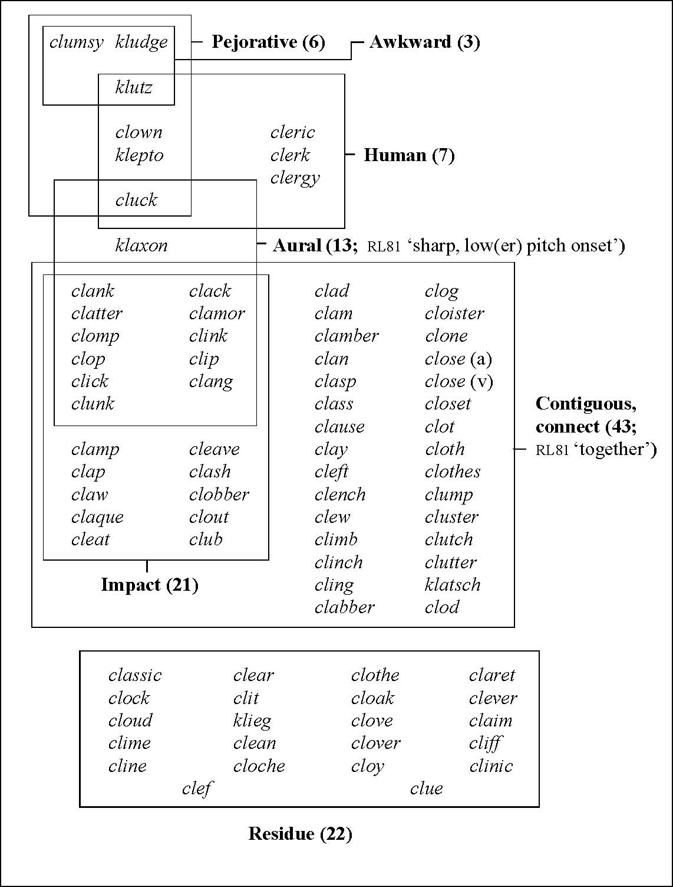
84 Simplex Words with Assonance KL-Coherence 62/84 = 74%
From J. Lawler 2009. “The Data Fetishist’s Guide to Assonance Coherence”
(RL81 = Rhodes & Lawler 1981. “Athematic Metaphors”, CLS 17 )

