Q: I want to apply online. Do I need to apply to Rackham Graduate School or should I apply to
the College of Engineering?
A: For a MS/MSE/PhD or SGUS Degree you will need to apply to Rackham.

Q: Do I need to apply for Financial Aid separately?
A: All applicants who indicate a need for financial aid on the admissions application will
automatically be considered for aid; however GRE scores are also required for financial aid.

Q: Can I get the application fee waived?
A: Applicants interested in applying for a Rackham Application Fee Waiver can email
rackhamappfees@umich.edu for more information.
Also see link below for information: http://rackham.helpserve.com/index.php?_m=downloads&_a=downloadfile&downloaditemid=34

Q: How can I obtain my University of Michigan Identification Number (UMID)?
A: You will receive your University of Michigan ID number approximately 7-10 business days
after you register as a Future Rackham Graduate Student. Use this ID number in all
correspondence with the University.

Q: Can I apply to more than one program?
A: Yes, but you will need to submit a complete new application and pay an application fee for
each program separately.

Q: After being admitted to your program will I be able to defer my admission?
A: Yes, you will be able to defer your admission for up to one year. A letter or email requesting
permission to defer admission should be sent, by the applicant, to the graduate program along with
an explanation for the request.

Q: Do you offer classes online or at night?
A: No, we do not offer online or night classes.

Q: Do I have a better chance to be admitted if I send documents like my resume, transcripts,
or my published papers to individual faculty?
A: No, all applications are reviewed and admissions decisions are made by our departmental
admissions committee. After you apply online your records will then be available for
interested faculty to review.

Q: Do you accept applications for all terms?
A: We prefer to only admit students to start in the fall term because of the order the classes
are offered and because our courses are only offered 1 time per year. Also Financial aid is
much more limited for winter applicants.

Q: How long does it generally take to complete a M.S, M.S.E?
A: Master’s degree students usually finish in 1 to 1.5 years (2 to 3 terms).

Q: How long does it generally take to complete a PhD degree?
A: PhD degree students usually finish in 4 to 5 years.

Q: Will you consider my application before my last semester’s transcripts are mailed?
A: If you otherwise meet the qualifications for admission, you will be accepted, pending receipt
of your final transcripts.

Q: Will I be notified if something is missing from my application?
A: Yes, as we go through our review process, we will notify you, by email if you are missing
something.

Q: When will I know if I’m admitted to the program or not?
A: Our Admissions Committee makes decisions as they review applications. Once they have
made a decision on your application you will be notified by email. All decisions are made no
later than the April 15 deadline.

Q: I have an engineering degree, but not in Naval Architecture and Marine Engineering. Can I
still be accepted in your graduate program or do I have to start as an undergraduate
student first?
A: These cases are handled individually. Generally some additional course work is required.
Typically this involves 1 or 2 undergraduate classes in addition to those required for the
Master or PhD degrees.

Q: I realized after finishing the online application that I made a mistake. What do I have to do to correct this?
A: Please send an email to Rackham (rackadmis@umich.edu) if you applied for the MS/MSE or PhD Program.

Q: I am interested in pursuing another Engineering’s Masters degree while working on my NA&ME Masters degree. Do I say Yes to the question “Are you applying to a Dual Degree? (see page 5 on your Online application)
A: See screen shot below (page 5)
- Question “ Do you want to apply to more than one Rackham masters degree?”-For a dual masters degree between 2 Rackham Masters programs, for example NA&ME and Mechanical Engineering, you can put down - Rackham Program 2: Mechanical; then after starting your NA&ME masters program, you can fill out a Dual Degree Application; see Nathalie Fiveland (221 NAME Bldg) for more information during your first term here.

- Question “Are you applying for a dual degree program?” Only answer Yes to this question, if you want to do the Rackham and (Non Rackham) Business School Joint Degree (NA&ME and MBA degree) otherwise answer No.

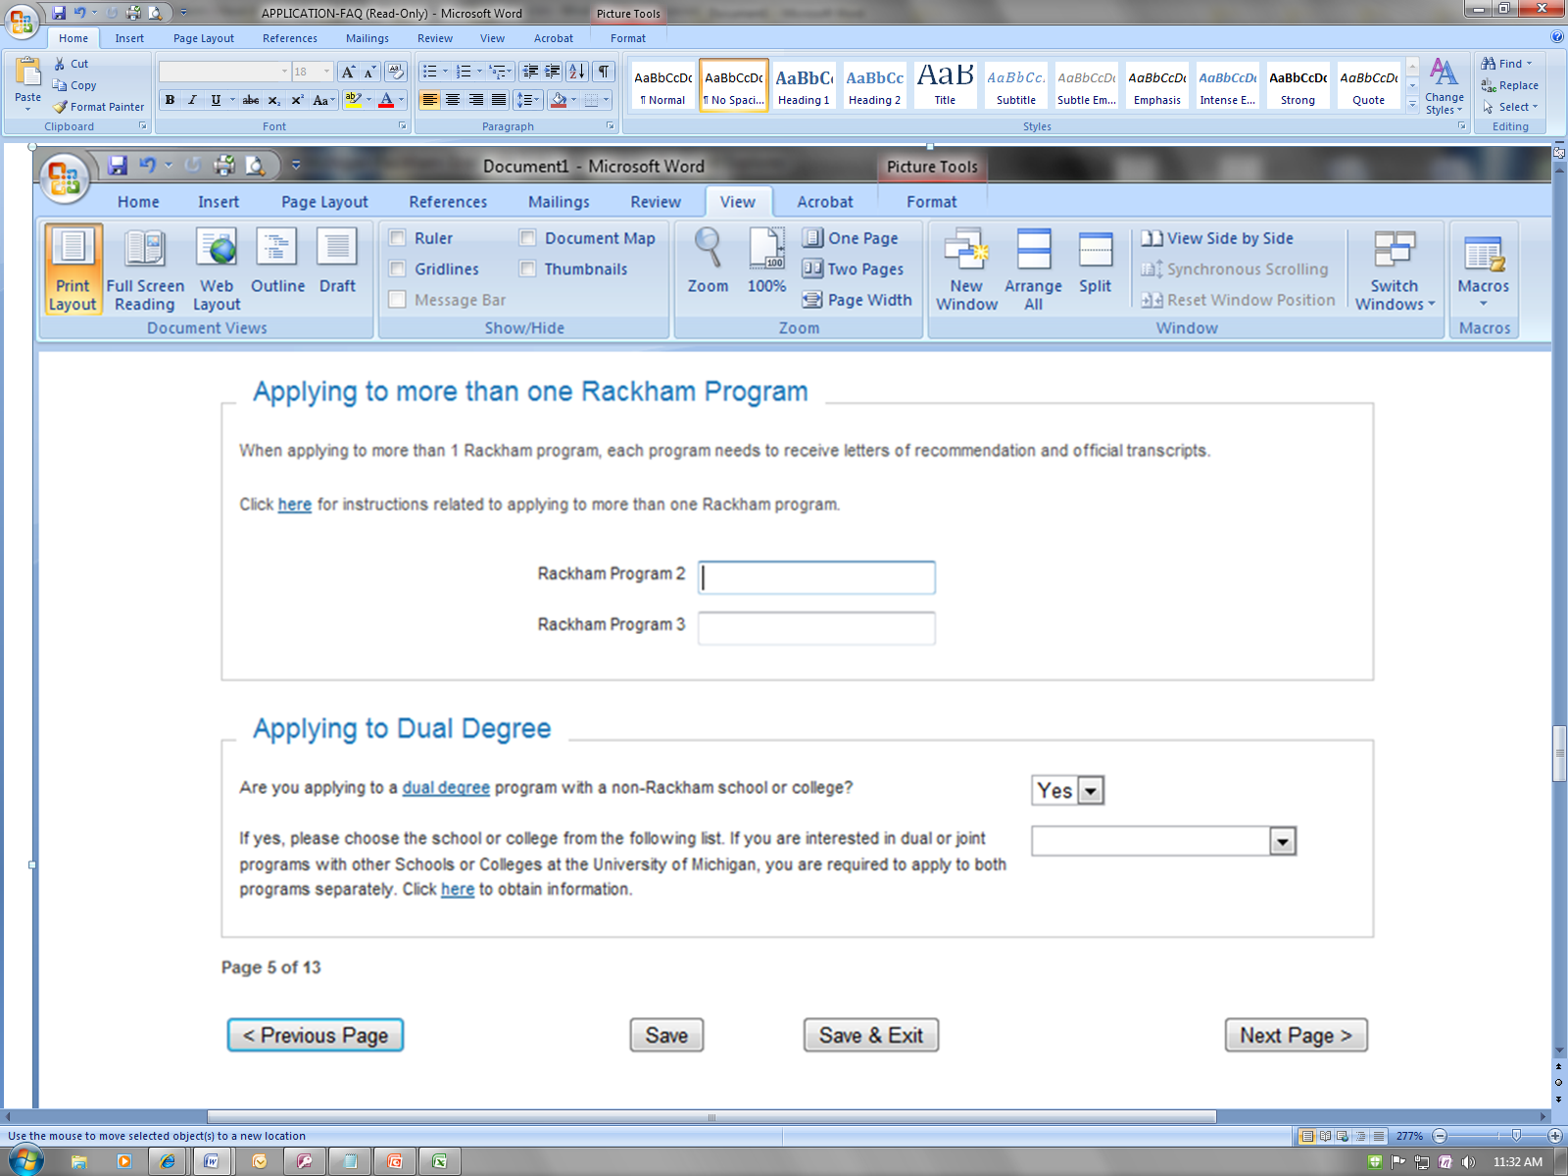

Q: How much is the Tuition to attend a Naval Architecture and Marine Engineering’s
Program?
A: See link below for information about tuition for Engineering Programs
http://ro.umich.edu/tuition/full.php#Grad_Eng

Q: I have submitted my application what do I do now?
A: For questions you might have after you submitted your application see link below.
http://www.rackham.umich.edu/admissions/applicants/

Q: I have been offered admissions how do I accept/decline my decision?
A: Create a U-M Friend Account at https://friend.weblogin.umich.edu/friend/
After you create your U-M Friend Account, log into Wolverine Access to view your application data; you will need your U-M ID number in order to access Wolverine Access (see link below) http://wolverineaccess.umich.edu then click New and Prospective Student Business.

Q: How do I know when I will be able to register for classes?
A: You can check this by logging into Wolverine Access. Click student business go to
Registration /Enrollment appointment

Q: I’m not sure what classes to register for, can somebody help me with this?
A: You will receive an email from the department letting you know who will be your advisor
(temporarily); any questions you might have about classes you will be able to ask your
advisor. If you want to register before that, you can always email our faculty. You can
check on NAME’s website about their Area of Expertise.

