University of Michigan, Ann Arbor

Singapore Students’ Association

New Students’ Welcome Program 2005
Formal Tea Session
23rd July 2005

Fellow Wolverine,

Welcome to the University of Michigan! This document serves to inform you of the administrative details regarding the New Students’ Welcome Program Formal Tea Session.

Venue

The Tea Session will be held at the Skylab in the Civil Service Club, Tessensohn Clubhouse.

Itinerary

The program for the day is as shown below:

Time | Program
12:30pm | Arrival of guests
13:10pm | Address by President of UMSSA
13:15pm | Screening of New Students’ Welcome Program Video
13:30pm | Address by Mr Matt Matthias,  “Studying in Umich: An American Perspective”
13:40pm | Address by Mr Dennis Teo, President, University of Michigan Alumni (Singapore Chapter)
13:50pm | Presentation on Umich Survival Guide
14:10pm | Q&A Session
14:30pm | Freshmen-Facilitators Mixer Session
14:50pm | Tea & Academic Advising Session
15:30pm | End of Tea Session

Dress Code

You are kindly invited to attend the session in smart casual attire.

Driving & Public Transport Instructions

Please refer to the map and instructions shown below if you are unfamiliar with the event venue.

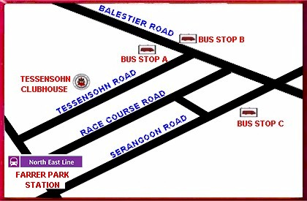

Bus Services:
BUS STOP A - 21, 125, 130, 139, 145, 648
BUS STOP B - 125,130, 139, 145, 648
BUS STOP C - 21, 23, 64, 65, 66, 67, 125, 130, 139, 147, 857
Parking
Below shows the parking rate at the Tessensohn Clubhouse.
Operation days | Members |  | Non-members
 | Hourly | Per Entry* | Hourly | Per Entry*
 | 8am-5pm | After 5pm | 8am-5pm | After 5pm
Monday - Saturday | $0.82 | $1.22 | $1.22 | $2.04
Sun & Public Holiday | NA | $1.22 | NA | $2.04
Motorcycles | NA | $0.60 | NA | $1.00
* Applicable only after 1700 hrs.

Please revert on your attendance at rsvp@umssa.org. We would also appreciate feedback on your parents’ attendance at the tea session.

In case of any emergency, you can also call the following numbers:

Goh Jia Yong, Co-ordinator, NSWP 2005 96642085
Tommy Teo, Co-ordinator, NSWP 2005 91796505

We look forward to meeting you at the NSWP Formal Tea Session. Go Blue!

Regards,

Goh Jia Yong

Vice-President (Internal Affairs)
Singapore Students’ Association
University of Michigan, Ann Arbor

